Nine facts about Giuseppe Arcimboldo
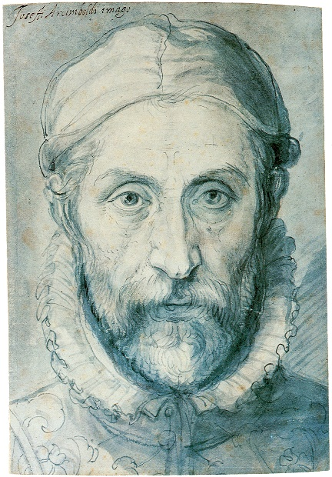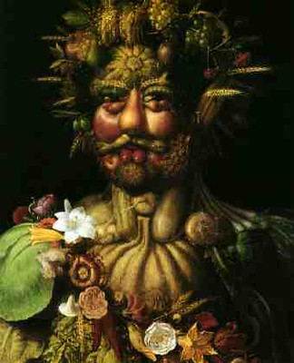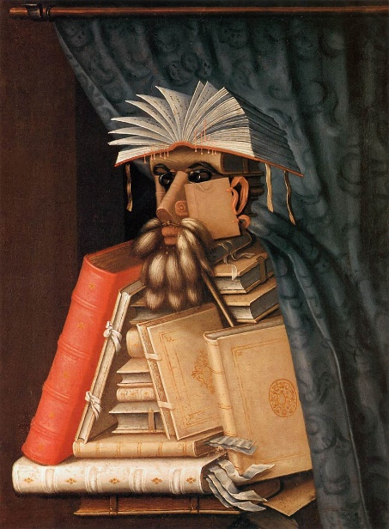
- Biagio Arcimboldo was the father of Giuseppe Arcimboldo and worked as an artist in Milan. The young Arcimboldo followed in his father’s footsteps, working at local cathedrals until he was 21 painting frescoes and designing stained glass.
- In 1562 Arcimboldo became court portrait artist for Ferdinand I in Vienna.
- He then moved to Prague where he was portrait artist, costume designer and court decorator for Maximillian II and his son Rudolph II.
- In 1570, Arcimboldo impressed the then Elector of Saxony, Augustus, with his work ‘The Four Seasons’.
- He had an unique portrait painting style, replacing features on the human head with imaginative objects such as fruit and vegetables, sea creatures and books.
- At a distance, his portraits look like human heads – but on closer scrutiny the features are transformed using an array of objects.
- He often incorporated everyday objects that reflected the background of the portrait. In one of his paintings, the animal tails used for the beard represented the tails used as dusters in the library.
- Arcimboldo criticized the behaviour of the rich. He hated the fact that many collected books but never actually read them.
- He created a portrait of Rudolph II during the last days of his career, having moved from Prague to Milan where he died.

