A Golden Harvest
All harvests were golden with the change from green to yellow.
What memories, starting with scything the entrance into the field where the corn had ripened.
Scything by hand an area through the gateway and around the perimeter of the field meant the tractor and binder would not trample it down. Horses were used before that.
Sitting on the binder, with foot pedals, working the sheaf carrier and dropping them in a heap of six for barley and eight for oats. This allowed one to then stand them in a shock/stook allowing the grains to dry. Always having to put the sheaves with the string knot on the inside of the shock so if it rained it would not gather and drip from the knot
As the photos show, the sheaves were then collected with one person driving the tractor and pitching the sheaves onto the trailer with someone else on the trailer “building the load”.
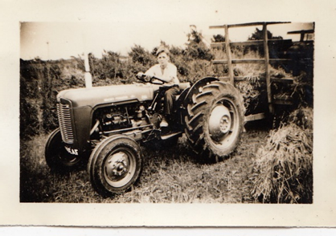
When the load was complete between the lades a rope was sent from back to front and the load was made secure.
Back to the farmyard for unloading and building the rick. On the ground was placed bracken and tree cuttings to keep the first sheaves off the ground to stay dry and the then building started always with the ears of corn facing inward.
At about 8 feet, a layer of sheaves was placed just proud of the of the layer below. This was known as the Hovis ring and I have no idea why. Then backing out started where sheaves were placed so each layer was narrower than the previous one until a peak on top was put straw to thatch the rick.
When all had been safely gathered in, traditionally someone would “oller the crow” which meant anything left in the field was for the birds.
The rick would stay in place until grain was needed to feed the farm animals and the threshing set would arrive for a day’s threshing. A wonderful time and a day off school.
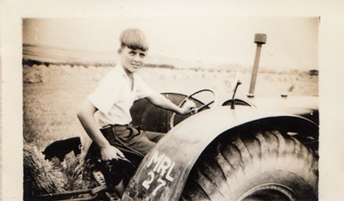
Happy days and wonderful memories. Who am I?

