Diwali – the Festival of Lights
Diwali, also known as the Festival of Lights, is celebrated on Aso Vad Amas and signifies the victory of good over evil. It is celebrated by Hindus, Sikhs and Jains.
For five days, children and adults come together and joyously celebrate. Hindu families start preparing for the goddess Lakshmi’s arrival weeks in advance by decorating their porches with colourful designs, or rangoli, preparing sweets and savouries, and lighting divos.
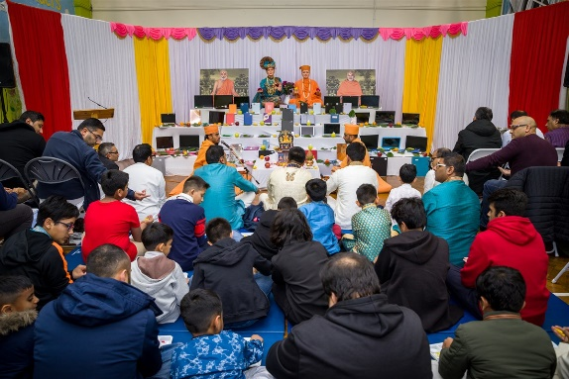
On the night before Diwali, devotees light divos – symbolically asking Bhagwan to expel their ignorance and enlighten their souls.
Lights, candles, and fireworks are an integral part of the festivities. The festival starts on Dhan Teras, when devotees pray to the Goddess Laxmi for ethical economic prosperity and success in their careers. The festivities then continue with Sharda Pujan, when businessmen and students purify their accounting ledgers and academic books.
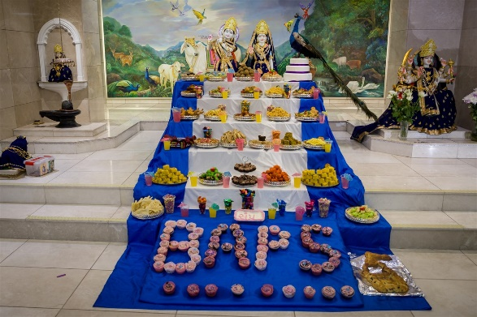
BAPS mandirs around the world celebrate Diwali. Thousands of families gather at the mandirs to celebrate the festival in a traditional fashion. The celebrations include delectable vegetarian cuisine, cultural programs, and forms of traditional entertainment. Special Diwali celebrations are organised for children and youths to preserve the true spiritual import of the festival.

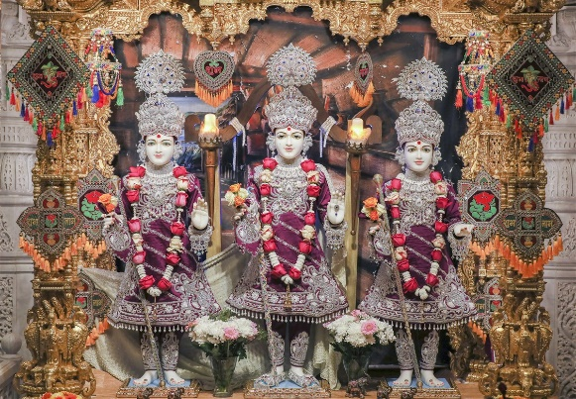
History
There are several stories related to the origins of Diwali:
- Shri Krishna vanquished Narkasur, an evil demon, releasing people from captivity and misery.
- The Goddess of Wealth, Laxmiji, emerged from the ocean when the devas and asuras were churning the ocean in search of amrut.
- Lord Pruthu extracted goodness from the Earth.
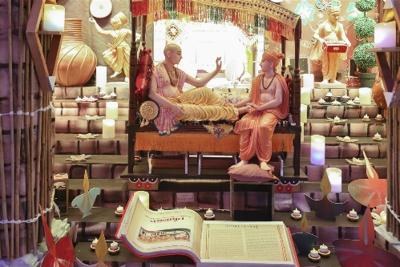
- The Pandavas returned from their 13 years exile in the forest.
- Shri Rama returned to Ayodhya after defeating Ravan in Lanka.

Rituals:
- Businessmen and students perform Sharda Pujan to purify their business ledgers and academic books for the coming year.
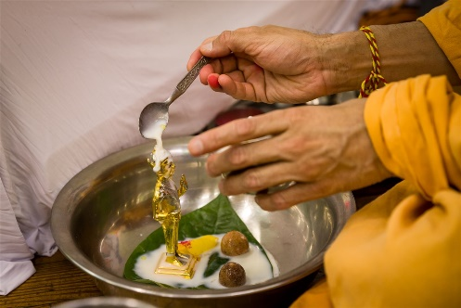
- People light divos and ask Bhagwan for inner enlightenment.
- Lights are used to decorate houses, mandirs, and communities.
- Fireworks are lit to celebrate the festivities.
- People decorate their porches with colourful designs and patterns called rangolis.
- People forgive and forget the misdeeds of their peers in the last year.

