Festivals and celebrations
Match the pictures to the festival or celebration, for example Christmas is 1/c
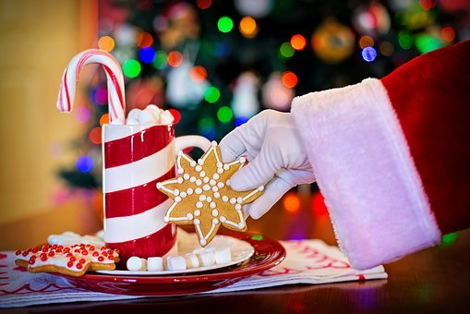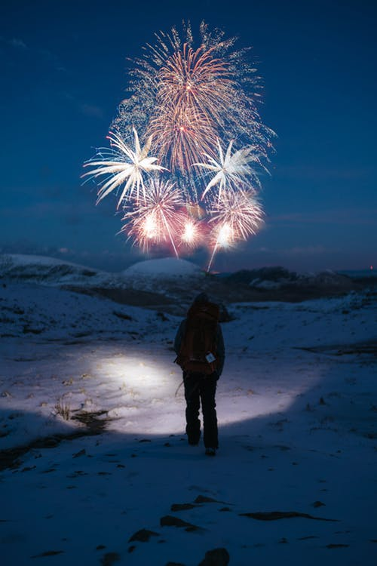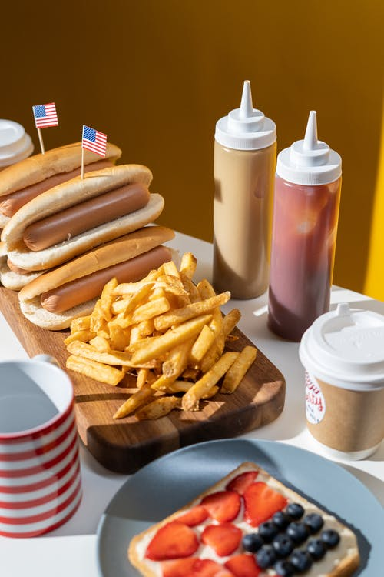
1 / 2/ 3/

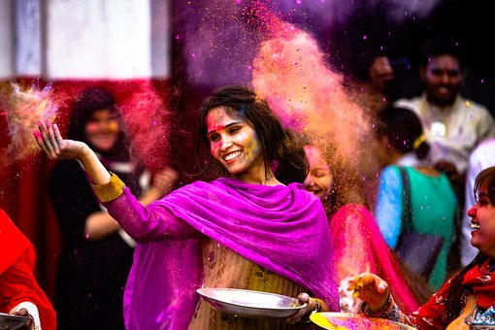 4/ 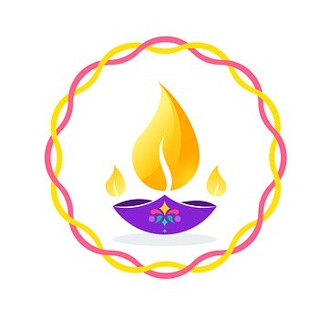5/

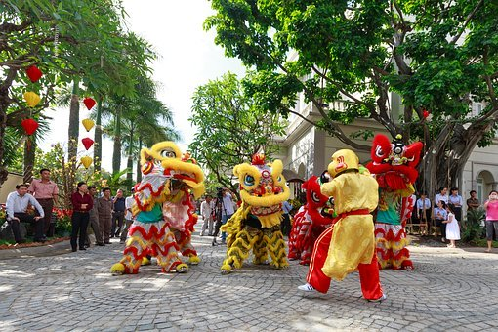 6/ 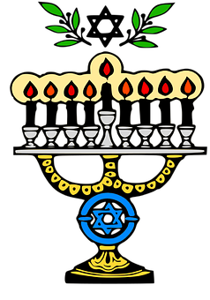7/
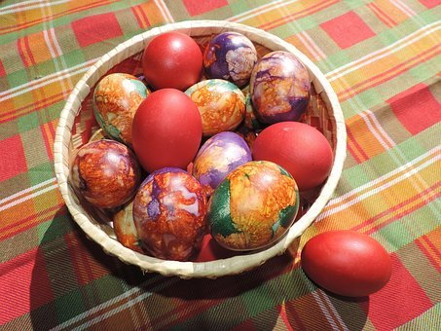 8/ 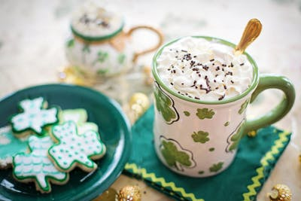 9/ 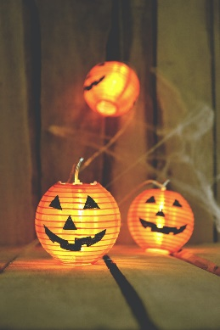 10/

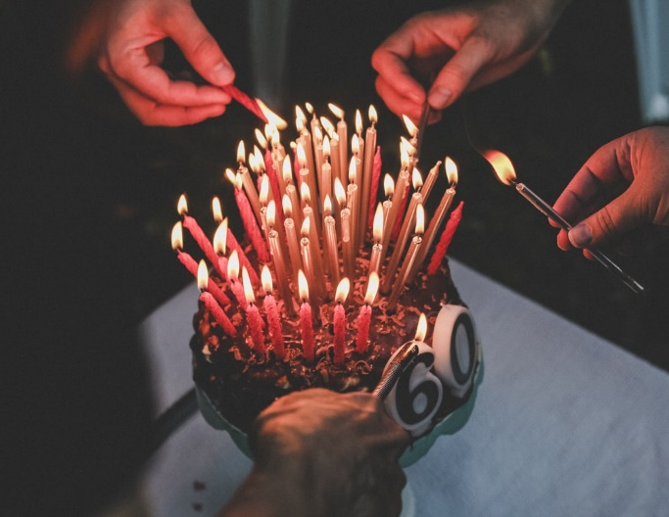 11/ 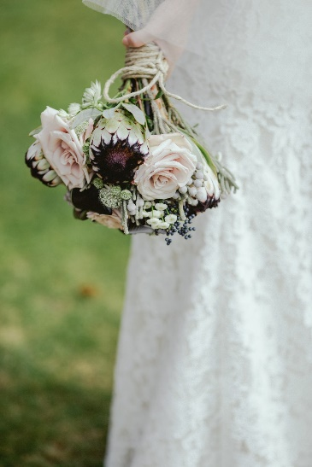 12/
- Easter - Christian Festival in Spring

- Wedding – a ceremony where two people are united in marriage

- Christmas - Christian festival celebrated on 25 December.

- St Patrick’s Day - Irish Holiday celebrated on 17 March

- Guy Fawkes Day - celebrated on 5 November with fireworks to remember the failure of the Gunpowder Plot to blow up the Houses of Parliament in 1605

- Chinese New Year - Celebrated in January/February. 2020 is the year of the Rat and 2021 will be the Ox.

- American Independence Day - Celebrated on 4 July

- Birthday – anniversary of the birth of a person, celebrated with gifts, cards, birthday party with cake

- Holi; Indian Spring Festival called Festival of colours where participants spray paint at each other.

- Diwali: Indian Autumn festival of light

- Halloween: the night of 31 October, the eve of All Saints’ Day

- Hanukkah: Jewish festival of light celebrated in Nov/Dec.

Answers:

Christmas - 1/C Guy Fawkes – 2/E American Independence Day - 3/G
Holi 4/1 Diwali 5/K Chinese New Year 6/F
Hanukkah 7/M Easter 8/A St Patricks Day 9/D
Halloween 10/L Wedding 12/B

