Test your knowledge with our fire-themed quiz!
- What year did the Great Fire of London take place?

- Which mythical bird sets fire to itself before being reborn from the ashes?

- Pugh, Pugh, Barney McGrew, Cuthbert, Dibble, Grub – was the roll call of which television fire brigade?
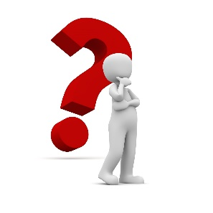
- Who in mythology stole fire from the Gods to give it back to man?

- The 2009 novel ‘Catching Fire’ by Suzanne Collins was the second book in which trilogy?

- Which famous person is mentioned first in the lyrics of the Billy Joel song ‘We didn’t start the fire’?

- Who famously set his guitar on fire at the Monterey Pop Festival in 1967?

- Which book in the Harry Potter series mentions ‘Fire’ in its title and which number book is it in the series?

Answers on the following page!

Answers

1. 1666 2. Phoenix 3. Trumpton

4. Prometheus 5. The Hunger Games 6. Harry Truman

7. Jimi Hendrix 8. ‘Goblet of Fire’ – 4th in series

