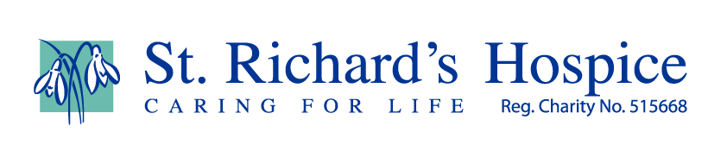

Harvest
I think we can all agree this year has been unusual.
Perhaps Easter was not the usual welcome long weekend camping trip, or the traditional family gathering, or scavenging at the local organised Easter egg hunt.
Perhaps summer did not herald the annual BBQ party where family, friends and neighbours are invited.
And what about festivals? Worcester Food Festival, Pershore Plum Festival, Worcester Music Festival, Evesham Asparagus Festival, Worcester Beer Festival, Eastnor Chilli Festival, Glastonbury – and many, many more across the country.
All these things mark the passing of the year, and are regular events in the calendar of the social consciousness.
Even though the seasons move through their stages of British variety, without these familiar markers of time I feel as though there has been little or no definition to the year.
For me, (putting any religious associations or church events aside where an out of date tin of beans is generously presented at the altar of the plaited harvest loaf), Harvest is one of these time markers. It happens regardless.
The hedgerows glisten with the richness of blackberries, apple and pear trees are begging to be picked for as many pies or crumbles as they will fill, neighbours offload their excess courgettes and runner beans, happily received. Conkers are worth the foraging whatever our age, either for their ascetic beauty as a seasonal table decoration or for a favourite game. Allegedly they even help to deter spiders!
Harvest time provides a grounding in the year when other familiar markers are lacking or absent.
Although Harvest sadly marks the end of summer, it is a short period of time which I love. The air smells and feels different and the light seems slightly adjusted.
We can indulge in making fruit crumbles or trying our hand at making fruity drinks or wine. It also brings to mind that soon some wildlife will start to hibernate so we could provide some food left outdoors to help fatten up the hedgehogs to help them through their hibernation. Contrary to common belief, bread and milk is not good for hedgehogs as it gives them diarrhoea. Regular ‘wet’ cat food without gravy is considered suitable.
I hope that this year, despite everything else, harvest might have a meaning and significance for us all that can outvie Covid-19.

