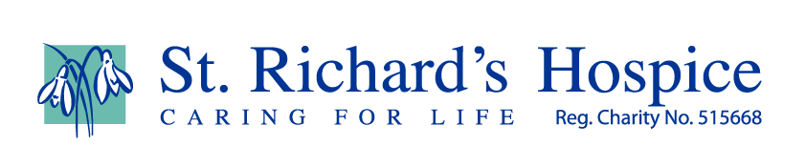

Key festivals in November
- On Sunday, October 25th at 2am, the clocks in the UK will go back one hour. It is officially the beginning of Winter Time and the same thing will happen all over Europe. Interestingly, though, all the countries in the EU have voted to stop doing this from next March onwards. The UK alone from then on will keep changing its clocks spring and winter, all thanks to Brexit!

- November, the month ahead, is often a dull one, mood wise, for many people, with the ever decreasing number of hours of daylight. Traditionally people have turned to Religion in general for inspiration and to Festivals in particular to reflect this sombre mood and cheer themselves up.

- It is also a time of year when people remember the dead.

- Nov 1st: All Saints' Day, known as All Hallows' Day, Hallowmas, the Feast of All Saints, or Solemnity of All Saints.

- It is a Christian solemnity, celebrated in honour of all the Saints, known and unknown, famous and quite ordinary, from people like St Paul to our own deceased relatives. (The word ‘Saint’ should best be understood to refer to anyone who has passed through death and is with God in the Resurrection.)

- In places where All Saints' Day is observed as a public holiday, cemetery and grave rituals such as offerings of flowers, candles and prayers or blessings for the graves of loved ones often take place on this day. In Austria and Germany, godparents gift their godchildren Allerheiligenstriezel (All Saint's Braid) on All Saint's Day, while the practice of souling remains popular in Portugal. It is a national holiday in many Christian countries.

- The Christian celebration of All Saints' Day and All Souls' Day stems from a belief that there is a powerful spiritual bond between those in heaven (the "Church triumphant"), and the living (the "Church militant").

- The Feast was historically given this date to replace the pagan Celtic Festival of Samhain when it was believed spirits of the dead visited people’s homes. Visit many shops today, see the masks and the many weird costumes on sale and you can see that the idea of All Hallows evening or Halloween is very much alive today.

- Nov 5th. Bonfire Night. This does not need any explanation to most children. Its beginnings are clouded in 17thc politics and fanaticism and maybe best left there as people today just enjoy all the fun of the fireworks.

- Nov 7th: Diwali. This is a five-day festival of lights, celebrated by millions of Hindus, Sikhs and Jains across the world. Diwali, which for some also coincides with harvest and New Year celebrations, is a festival of new beginnings and the triumph of good over evil, and light over darkness.

- Nov 8th Remembrance Sunday. This marks the day World War One ended, at 11am on the 11th day of the 11th month, in 1918. A two-minute silence is held at 11am to remember all the people who have died in wars and in the service of their country. Very moving tribute are held throughout the country and the world.

- Nov 23rd the birthday of Guru (Great Teacher) Nanak, the founder of Sikhism. Sikhism is originated in the 15th century in the Punjab region of the Indian subcontinent. The term "Sikh" means a disciple or student. They follow the Teachings which are contained in their Holy Book the Guru Granth Sahib. Over four hundred thousand Sikhs live in England today. Many of them are our Midland neighbours.

- Nov 26th Thanksgiving Day is an annual national holiday in the United States and Canada celebrating the harvest and other blessings of the past year. Americans generally believe that their Thanksgiving is based on a 1621 harvest feast shared by the English colonists (Pilgrims) of Plymouth and the Wampanoag people. It is a time for relaxing and having a big meal with all their families.

- Nov 30th St Andrew Day. St Andrew has been celebrated in Scotland for over a thousand years, with feasts being held in his honour as far back as the year 1000 AD. However, it wasn't until 1320, when Scotland's independence was declared with the signing of The Declaration of Arbroath, that he officially became Scotland's patron saint. His name has been given to Scotland’s oldest University and his cross is on the national flag. On this day, you visit Edinburgh Castle is free.

- Let’s all try enjoy the month ahead as best we can then.

