The Land of Light at Longleat Estate, Bath
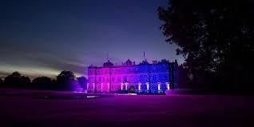
Between 2nd December 2020 and 10th January 2021, the Longleat Estate will hold their brand new festival event, Land of Light.
Winding across the Longleat Estate, pathways will take you on a magical journey through the winter wonderland.
Explore sensory spell binding walks and see the magical light illuminations, motion-detected splashes of colour and movement which are synchronised to soft music.
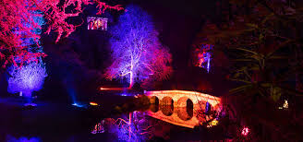
The Eastern Terrace presents a stunning spring bloom display, at Half Mile Lake the waters will come to life with a display of colours dancing across the fountains and spray.
As you pass through the Summer Storm, you will experience the electrifying heat before reaching the Peacock Gardens, serene and calm in their autumnal colours.
Continuing on this magical journey, you will enter the coolness of the Love Labyrinth, a shimmering winter maze with elaborate mirrors and icy LEDs.
The Longhouse is the venue for a Laser Show, an amazing 360 degrees infinity experience where you will be surrounded by cascading light and breath-taking colourful beams at the floor-to-ceiling optical and aural show.

For more information, visit www.longleat.co.uk/land-of-light/discover-the-land-of-light

