A fiery recipe for you to try
Without sunlight the world would be very different. We rely on the Sun – the star at the centre of our star system. Its light enables plants to photosynthesise, converting carbon dioxide from the atmosphere and water into plant proteins so the plants grow. In turn these plants provide food for herbivores which in turn become prey for the carnivores. In this way some very complicated food webs are built up. Every organism in a food web is vital to the existence of every other organism but it all depends on healthy, plentiful plants which all depend on the Sun. Biology lesson over!

We also enjoy the warmth of the sun in summer and miss it in the winter when days are so much shorter. Our walking hours are much reduced now with the darker evenings – we have memories of long evening walks earlier this year when it was light enough and warm enough too for walking in our magnificent county until almost 10 o’clock. Now we must be contented with some lovely sunny days with much cooler temperatures.

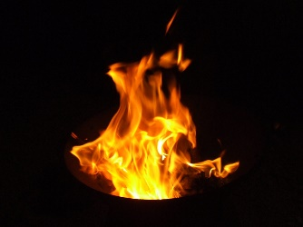
One bonus of the autumn is the enjoyment afforded by going back to childhood and walking through piles of beautifully coloured fallen leaves, scattering them with our booted feet. Their range of hues from brown to gold and vibrant reds reminds of the colour of flames in a fire. Fire can be a friend when we use it to keep us warm or cook our food; however it can be a foe too - thinking of the disastrous forest fires in California and elsewhere earlier this year or house fires. Fire is also a term used to describe the spiciness of food.
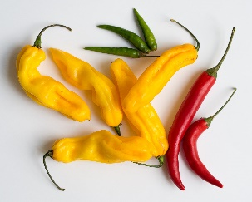
Chillies have their ‘fieriness’ measured by the Scoville scale – some chilis such as the Carolina Reaper are mouthburning yet people hold competitions to find out who can eat the most. No accounting for tastes!
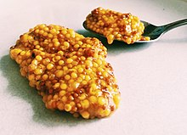
Mustard is another fiery substance to the tastebuds. English mustard is much more potent than its American equivalent –
pity the unsuspecting man from ‘across the pond’ who dipped his celery stick into some English mustard before eating it causing him immense discomfort!
Just to give you a less fiery experience, here is a recipe for a spicy marrow chutney which goes well with mature cheddar cheese. You will need:

2 kg of chopped marrow flesh
Salt
225g chopped onions
20g ground ginger
20g mustard seeds
20g turmeric powder
5g cayenne pepper
1 tsp ground cloves
1 tsp ground black pepper
1500 ml vinegar
500g sugar

Method
- Put the marrow into a large bowl, sprinkle salt over it and leave overnight.
- The next day pour away the liquid and rinse the salt from the marrow under the cold water tap.
- Put the marrow into a large saucepan (or preserving pan) and add the onions.
- Mix the powdered spices with a little of the vinegar in a cup and add to the pan along with the mustard seeds, sugar and the rest of the vinegar.
- Stir well and heat gently for about an hour stirring from time to time.
- When most of the liquid has been reduced allow to cool for 20 minutes and then pour into warmed jars (about 6 x 454g jars) and close with screw-top lids. Leave for a few months to mature and then enjoy!
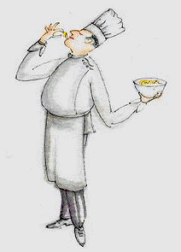
Bon Appetit

