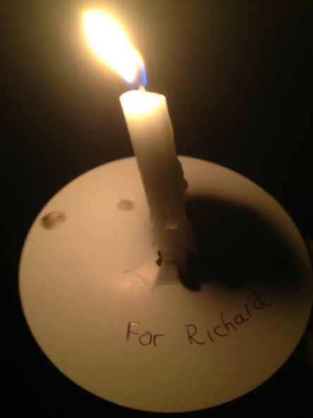
Lights of Love
We will miss the St Richard’s Hospice Lights of Love service this year, but I hope we will be united with our home candles burning and remembering all our loved ones.
As we enter the winter months, the lack of light affects us all.
A few years ago, I was given The Little Book of Hygge – The Danish Way to Live Well by Meik Wiking. It is a book that illustrates ways to make ourselves feel comfortable and, during this pandemic year, we all need to look after ourselves in the best way possible.
Candlelight is soft and comforting. If candles are not available, the flicker of a fire’s flames or softer side lights can create a similar effect. A beautiful throw or some warm socks help with the ‘comfort and cosy’ factor.

