Recipe for Sloe Gin, a perfect Autumn drink

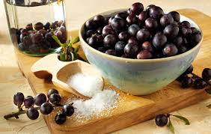
Ingredients
500g sloes
250g caster sugar
I litre gin
Method
Rinse the sloes and pat dry with a clean tea towel.
Prick the sloes (I use a cocktail stick) and put into a sterilised, two-litre glass jar such as a Kilner jar.
Add the sugar and gin, before sealing and shaking the jar!
Store the jar in a cool place and shake it once a day for seven to 10 days and leave for about three months.
Strain the gin through a fine sieve, and decant into clean sterilised bottles.
All that’s left to do then is seal and label your bottles!
The longer you leave the gin the better it will taste, I make mine and drink it the year after I have made it. It makes a great pressie. And, a small amount in a glass topped up with Prosecco is delicious!
Judy

