Festivals, carnivals and special days
What is the meaning of carnival?
The word “carnival” is thought to mean “farewell to meat” or 'fareward to flesh”, the former referencing the Catholic practice of abstaining from red meat from Ash Wednesday until Easter.
Mardi Gras meaning?
Mardi Gras is French for Fat Tuesday reflecting the practice of the last night of eating rich, fatty foods before Lent
Have you heard of Rochester's Sweeps Festival?
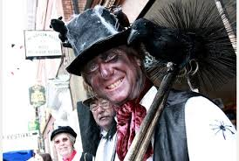
Rochester's annual Sweeps Festival celebrates the traditional holiday that chimney sweeps used to enjoy on May Day. It was one time of the year when the sweeps could put away their tools and have some fun. The Sweeps Festival is a colourful mix of music, dancing and entertainment. An opportunity to see some traditional dances and hear songs which have been passed down from generation to generation.
St Valentine's Day
We all know how to celebrate St Valentine's Day on 14 February but did you know he is also the patron saint of epilepsy
August is Family Fun Month
It is also Artist Appreciation Month and for little artists there are games to play. For those children in our families they may like the Crayon Scavenger Hunt as follows:
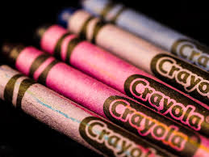
Take a large box of crayons. Divide the crayons into even amounts of groups. Make a list of the names of the colours in each group. Hide the crayons. Divide players into as many teams as you have groups of crayons. Give each team a list. Send them out to find their colours. When they come back with all the colours on their list, give them a colouring book. You can now have a simple colouring activity.
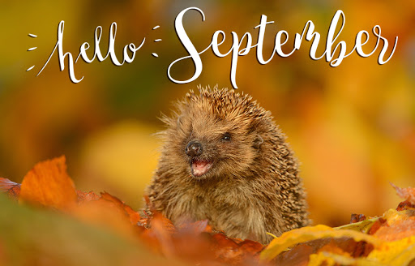
September is Positive Thinking Month. We may now be in October, but it’s never too late to practice positive thinking so:
Spend time with people who make you smile
Make the most of the late summer sunshine
Read a good book (suggested book: The Salt Path by Raynor Winn – a true story. “A tale of triumph: of hope over despair; of love over everything – Sunday Times”).

Here is a link to some month by month special days and festivals held in Great Britain.
http://projectbritain.com/calendars/index.html

