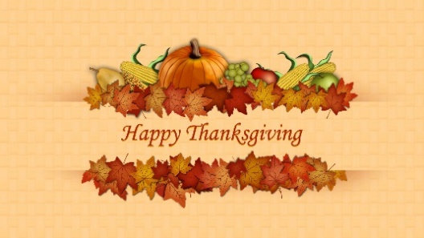
Thanksgiving
An annual national holiday in USA and Canada celebrating harvest, and blessings of the year.
In the USA it is celebrated on the third Thursday of November. In Canada it is on the second Monday of October. Originally a religious occasion it is now primarily a secular holiday.
The first Nationwide American Thanksgiving was proclaimed by George Washington on November 26th 1789. Federal legislation set the date as the third Thursday in November in 1941.
Thanksgiving is a time to give thanks for all you have. For some families it is the main time of year to meet and socialise. It is less commercial and has no specific religious attachment. It is also the start of a four-day break for many.
Canadian Thanksgiving predates American Thanksgiving by 43 years. In 1578 the first Thanksgiving was in Newfoundland Canada. In 1621 the first American Thanksgiving was celebrated at Plymouth Plantation, Massachusetts.
The day after Thanksgiving is a busy one for plumbers! Who unofficially call it ‘Brown Friday!’
There is a grocery in Paris called ‘Thanksgiving’ which sells American food brands to homesick ex pats.
In 2013, the manager of a Pizza Hut in Indiana was fired for closing shop so that his employees could celebrate Thanksgiving with families! He was later reinstated!
The Salvation Army enlist volunteers to serve Thanksgiving dinners to hundreds of poor and homeless across the USA.
Unofficially, five days after Thanksgiving, ‘Giving Tuesday’ is encouraged as a celebration of charitable giving.
In 1953 the SWANSON company had around 260 tonnes of leftover turkey after the Thanksgiving weekend. An employee suggested it be packed in trays with vegetable sides and frozen – becoming one of the very first TV dinners.

