The Harvest Moon
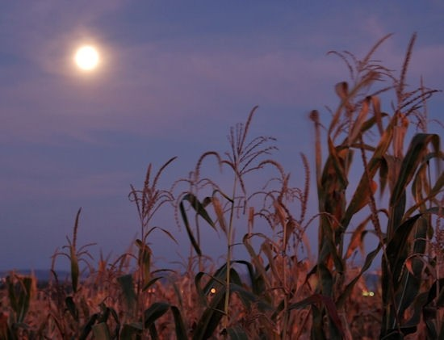
The full moon which is closest to the Autumn Equinox is known as the Harvest Moon. In the Northern Hemisphere, where the UK is located, the Autumn Equinox falls on 22 September 2020 and the Harvest Moon will be visible on 1 October – provided there is no cloud cover obscuring this magnificent sight.

Why Harvest Moon? You may well ask …
Whilst it is a full moon, it does have certain characteristics which differentiate it from others appearing throughout the seasons. The harvest moon rises closer to the time of sunset, appears low on the horizon, and lasts for a couple of evenings.
The place of the moon when orbiting the earth will determine how it will appear to the naked eye. In 2019, the Harvest Moon appeared as a micro-moon because it was much further away. In 2020 the Harvest Moon will be the second-smallest full moon – yet five years ago, it appeared as the biggest and closest supermoon.
In spite of its apparent size and distance from the earth, a Harvest Moon always looks bigger, brighter or more orange in colour creating a powerful and mysterious image in the sky. This is because of its position just above the horizon which plays tricks on your eyes called the Moon Illusion.

And its name …
Before the advent of electrical lighting, famers used the abundance of light from the Harvest Moon to gather up their crops, as daylight hours faded and fields were lit up by this natural phenomenon.
Perhaps the farmers named it as such although it was characterised in the words of a song “Shine on Harvest Moon” by Nora Bayes and Jack Nortworth (1903)

Shine on, shine on harvest moon
Up in the sky,
I ain’t had no lovin’
Since January, February, June or July
Snow time ain’t no time to stay
Outdoors and spoon,
So shine on, shine on harvest moon,
For me and my gal.

