Learn about Advent
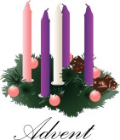
Christians use the season of Advent to prepare for the birth of Jesus at Christmas, let’s check out our facts …
Advent is a season observed in many western Christian churches as a time of expectant waiting and preparation for the celebration of the Nativity of Jesus at Christmas. The term is an anglicized version of the Latin word adventus, meaning “coming".
Latin adventus is the translation of the Greek word Parousia, commonly used to refer to the Second Coming of Christ. For Christians, the season of Advent anticipates the coming of Christ from two different perspectives.
The Season offers the opportunity to share in the ancient longing for the Coming of the Messiah, and to be alert for his Second Coming.
When is the first day of Advent?

Advent is the period preceding the Christmas season. It begins on the Sunday nearest November 29th, the feast day of St. Andrew the Apostle, and covers four Sundays. Because the day it begins changes from year to year, so does the length of each Advent season. In 2020 Advent begins on November 29th.
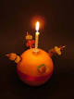
What do people do in Advent?

Some traditions associated with Advent include keeping an Advent Calendar, lighting an Advent Wreath, praying an Advent daily Devotional Prayer, holding Christingle Services, going Carol Singing, putting on Nativity Plays, as well as other ways of preparing for Christmas, such as putting up some decorations.

What is an Advent wreath and what does it signify?

The Advent wreath, four candles on a wreath of evergreen, is shaped in a perfect circle to symbolize the eternity of God.

In some churches, four purple candles, one for each week in Advent, are used with one larger white candle in the middle as the Christ candle.
What do Advent candles represent?

There are usually five candles, four purple and one white but in some locations, the third candle might be pink. The purple candles are lit during Advent, when the liturgical colour is purple, and the white candle is lit on Christmas Eve (that is, after sundown), when the liturgical colour is white. What do the candles symbolise?

The first candle is for hope. Jesus reminds us that God loves and cares for us. As long as we have hope, we can keep trying to do better.
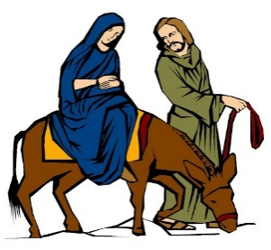
The second candle is for peace. We pray for peace everywhere and for everyone.
The third candle is for joy. Jesus brought joy to the world and asks us to share it with others.
The fourth candle is for love. In Jesus we see that God loves us, everyone of us. The challenge is to bring love to others, not just at Christmas but throughout the year.

