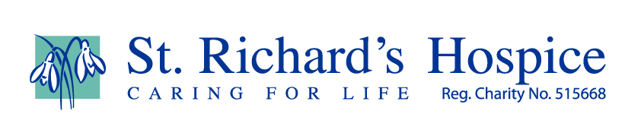

Find out about Woo Fest
Woo Fest is a multi-genre music festival for all ages that raises funds for St Richard’s Hospice.
It was created by brother and sister duo Luke and Ria Simons. It’s set in a beautiful location near Upton upon Severn at the Drum and Monkey.
It has gone from strength to strength since its launch in 2015, raising more than £75,000 towards hospice care. It has grown from a small festival of friends and family to the first on the festival calendar for many people locally.
Woo Fest received recognition at the prestigious UK Festival Awards, winning the Best Small Festival in the UK in 2019! Woo Fest was also awarded runner up in the Grassroots category and had been nominees at the awards in both 2017 and 2018.
The normal version of Woo Fest was cancelled this year due to Covid-19, however the festival moved online and took place on Saturday, 4th July raising £13,950.
Supported by the wonderful DRP Group at their studios in Hartlebury, the day ran in a similar vein to Comic Relief with free to air viewing and different donation options for St Richard’s Hospice. Audiences enjoyed a day of both live and pre-recorded performances from many great musicians and even the odd celebrity!
Visit the Woo Fest website: woo-fest.com
And find Woo Fest on Facebook: facebook.com/WoofestUpton
Woo Fest was set up in memory of a local man, John Simons, who died at St Richard’s Hospice in 2013 aged 66. Since then it’s grown considerably and touches the hearts of so many people. John’s son Luke picks up the story:
“In 2013, my dad had a really short battle with pancreatic cancer. Once we got the dreaded news from the hospital that there was nothing more they could do, our world started caving in – particularly as two weeks before we had no idea that he was even ill. Dad was on a typical hospital ward with lots of noise and people. He took the news very bravely, but I could see he was getting agitated being there.
“This is where St Richard’s stepped in and transferred him to its little oasis. He had his own room, we could stay as long as we wanted (even overnight), and we played all his favourite music. We watched cricket, spent time on his patio next to the pond, and we even celebrated his granddaughter's (my daughter) third birthday there. During this he also had absolutely amazing nursing care, and all the little details were sorted out: his Will, haircut, and we even had a curry delivered!
“I think the main thing it allowed us to do was to come to terms with what was going to happen and for everyone to be at peace with it. It’s amazing how we all accepted it. Looking back now, even the conversations around music for the funeral seemed very easy. One of the songs he chose was Alright Now by Free. I think for some reason he thought it would be amusing as in his words – “I won’t be alright – I’ll be dead!” My old man always had a slightly strange sense of humour!
“This may sound strange, but I actually enjoyed those few days. I have good memories and things would have been very different without St Richard’s Hospice. The support once my dad passed away was also great with even the offer of counselling for as long as required. Some of these things may even sound trivial but throughout the darkest time, we had dignity, comfort, fun and laughter.
“When I walked to reception for the first time, despite what I thought I knew about hospices, I remember thinking this is it – this is where people come to die. I now know that it's not, people actually come here to live, to get quality care and spend quality time with their families during those precious times. That is why they are so deserving of our support.
“In 2014 we wanted to give something back, so with some friends we organised a charity challenge along 140 miles of the river Severn that we called Source to Sauce. It was a great event and we raised some good money, but we found that we raised almost as much money at the party afterwards with over 100 friends and family than we did in sponsorship. So, during that night – after a few too many beers – I said to a friend we should organise a music festival next year. He kind of said yeah right whatever Luke. But I’m pleased to say that’s what we did, and it’s fitting as my old man was such a music fan.
“We now have five festivals and one virtual festival under our belt and have a really committed group of volunteers, sponsors, technicians and of course some amazing acts that have supported us over the years. Our customers have been incredible and really supported us throughout the years and come back time after time and we strive to put on a good day for everyone. So far so good!
“Our volunteers include people who have been personally touched by the work of the hospice, to people who simply want to support their community. In other words - amazing people!
“If you like good music and/or want to support such an important charity then why not join us at Woo Fest? Every single penny of your ticket will go straight to St Richard’s Hospice thanks to all our sponsors, volunteers and musicians.”
On July 15th 2020, sadly Luke’s Father In-Law, ex professional Cricketer David Humphries also died aged 66 and after a short battle with pancreatic cancer.
Before his death, David received hospice at home care from St Richard’s Hospice making the festival and fundraising even more poignant and close to the organisers’ hearts.

