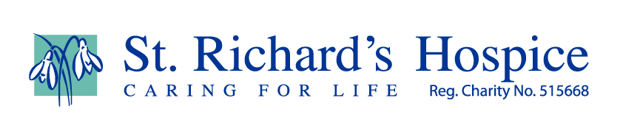

Films on an animal theme
Take a look at some of our animal-themed film suggestions for children and adults.
Jungle Book
The Lion King
Doctor Doolittle – starring Eddie Murphy
Lady and the Tramp
101 Dalmatians
King Kong
Babe
Ice Age
Noah – starring Russell Crowe, Anthony Hopkins (2014)
The Life of Pi
Madagascar 1, 2 and 3
Planet of the Apes – starring Charlton Heston and Roddy McDowell (1968). Or, 2001 film starring Mark Walhberg, Helena Bonham Carter
Happy Feet 1 and 2
Fantasia – The Sorcerer’s Apprentice (1940)
Flipper (1964)
The Adventures of Milo & Otis (1989)
Beethoven (1992)
Free Willy (1993)
Homeward Bound: The Incredible Journey (1993)
Marley & Me – starring Owen Wilson & Jennifer Aniston (2008)
Peter Rabbit (2018)
Paddington Bear

