Cats Tales – introducing the Prettykins Family
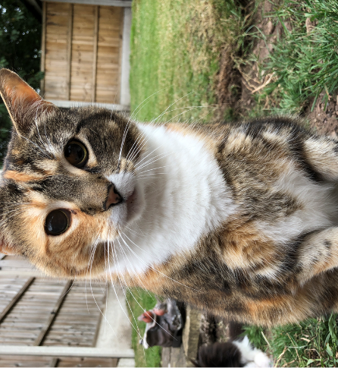 Hello my name is Lily and I am the top cat in the Prettykins Family. Why? You may ask yourself. Because I am the biggest, the cuddliest and the other cats adore me … my hooman mummy does too so I get lots of cuddles off her, ALL THE TIME.
I chose my hooman mummy nearly 8 years ago when I had an unexpected visit to the local vets when I was poorly and she came to see me … she made a real fuss of me and then I tried to climb into her handbag – I guess my cuteness won her over and we have been inseparable ever since.
Now I just love sleeping …sleep … sleep … sleep - on the fluffy blankets, in my cat bed, on the garden bench – give me somewhere comfortable to settle down and curl up, I am there instantly.
Now this photo of me is very flattering (thank you hooman mummy xx) however I have to confess I really, really enjoy my food and when I have finished mine I then empty the other cat bowls. My hooman mummy says “Lily, you really are getting a little chubby and will have to go onto Kitty Weightwatchers”.
One of my favourite pastimes is giving the other kitties a really good clean, especially Amber and Poppy … sometimes I have a queue forming and they give me no choice when they stick their heads in my face!! Mind you Poppy always looks like she has been dragged through a hedge by the time I have finished with her … the fur is all over the place and she looks completely bedraggled!!
Being in the garden is probably my favourite place, running around and rolling on the grass although occasionally I will sit on an ants’ nest and end up with ants in my pants … goodness gracious for such tiny little insects they have a nasty bite … ouch … ouch … ouch.
Hello, my name is Amber and as you can see I am a very 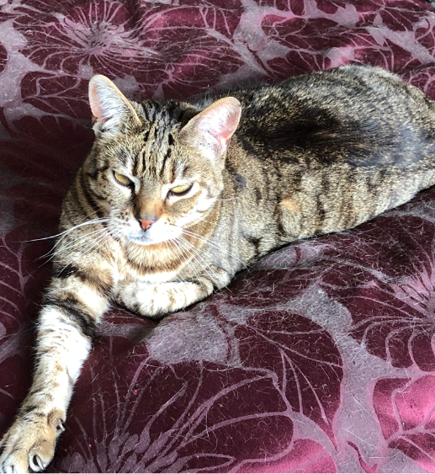chilled out cat who takes everything in her stride.
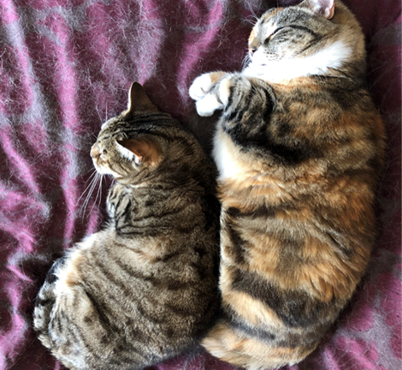 My big sister is Lily and I absolutely adore her … she is so sweet and very patient, letting me snuggle right up to her when it is sleepy bye-byes time as you can see from the VERY cute picture above … one, two, three, aaaaaahhhhhhh
Originally, I lived at the Blue Cross Rescue Centre in Burford and this is where my hooman mummy came to see me before deciding to adopt me.
I heard tell that she had travelled nearly 200 miles in a week making all the arrangements … I guess it was love at first sight for her, I know I love her with all my kitty heart.
I tend to keep myself to myself most of the time although I do enjoy my mummy cuddles with the hooman and when she tickles my tummy it is the only time I purr and it is a BIG purr.
I can be a chatterbox at times and have little meows with the other cats … my hooman mummy completely understands when I would like food, I want to go outside or hope for a fuss off her.
The twins can be troublesome at times … must be their age … typical 3 years old … like badly behaved toddlers the pair of them. I hiss at them really loudly and they will calm down.
For quite a lot of the time (and when it’s not raining) I sit under the big tree at the top of the garden and watch the birds … sadly they do not come down and say hello to me … I wonder why?
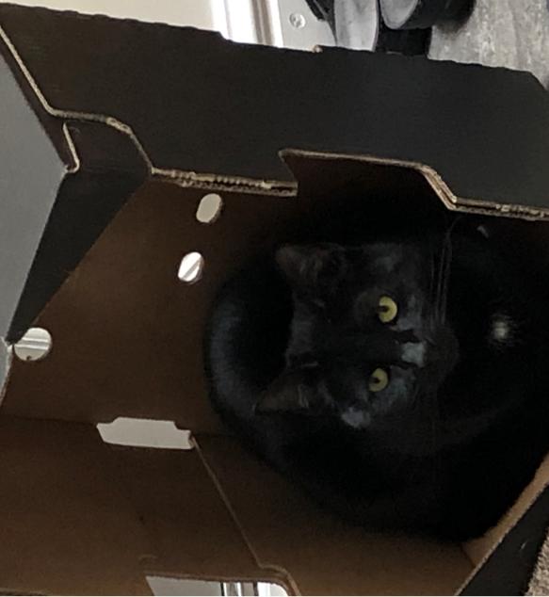 Hello peeps, have you heard of “Jack in the Box”? Well I am “Cat in the Box” … put a box on the floor and I will get in to it … sometimes I don’t fit if the box is too small however I will always give it a try.
I am Ruby Tuesday, apparently the hoomans named me after a Rolling Stones record and I am called “Rubes” for short as long as I behave myself. My twin sister is Poppy although we look nothing alike and she is feistier than me … I’m a little cutie meow.
One of my favourite things to do is scoop all the water out of the water bowls, needless to say it goes all over the kitchen floor and my hooman mummy cleans it up after me (these hoomans do have their uses you know).
I also like doing the “cat dance” around the garden as if I have springs attached to my paws, I can even do an impression of Basil Brush because, if I get spooked, my tail completely bushes out.
I can be a bit mischievous at times, playing Lily up whilst we are waiting for dinner to be served … because she doesn’t see very well I can sneak up behind her and catch her unawares … she knows I mean no harm but if I am unlucky, she will give me a clip around the ear with her paw.
Well now dinner time … let me tell you about that. I usually get on the kitchen table, meow a lot and try to look as cute as possible so my hooman mummy will then let me choose the dish of the day (we all think Felix is lush).
My hooman mummy has a piece of pink leather bootlace attached to a piece of elastic and when she waves that around in front of me, I completely lose all my dignity and bounce around the floor like a crazy cat chasing it and trying to take it off her … who needs expensive cat toys when a bootlace and piece of elastic will do.
I like mummy cuddles too … not for long though as I cannot sit still for 5 minutes especially when there are lots of flies around … I am known as the Feline Fly Catcher in the Prettykins household!!

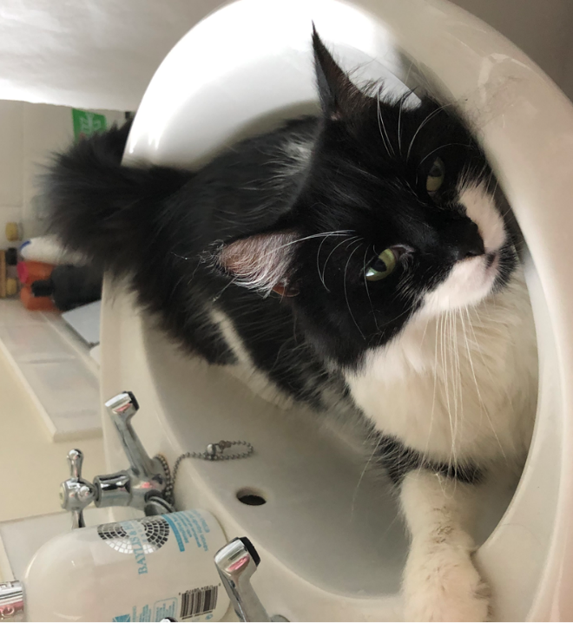 Hello everybody my name is Poppy or Poppykins or Poppy Socks or Pops or Poppy-cat-a-petal (I think that is a volcano in Mexico) … it really does depend on how well behaved I am … which is not often!!
The above photo was taken before lockdown restrictions when I would relax in the bathroom sink or paddle in the bath water … however my hooman mummy said I was making too much mess leaving muddy footprints everywhere so the bathroom door now stays closed … which makes me sad because I just love water, taps and puddles sooooo much.
I absolutely idolise my big kitty sisters, Lily and Amber because they are so nice and warm to snuggle up to. If I am really lucky, Lily will give my face and ears a good wash, then Amber will or, even better, they will both lick either side of my head … just heavenly.
When it is sleepy bye-byes time, I snuggle up by my hooman mummy in bed, padding her with my little paws for ages and snuffling into her, dribbling and drooling to my heart’s content … this makes me feel VERY happy and I get lots of fuss.
I will let you into a secret … I am a bit of an adventurer and when the hoomans are not looking, I will climb over the fence and explore the other hooman gardens … it is such fun. Then my hooman mummy will realise I have disappeared and shake a bag of treats calling “Dreamies” in a high-pitched voice … well do you think I can resist Dreamies? I love them too much and being the good girl, I am I will return home again.
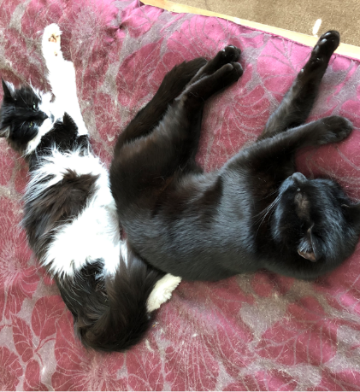Whilst me and Ruby don’t always get on, very occasionally you will find us curled up together on the bed … she is still my prettykins sister after all.

