King Charles II - The Flight from Worcester
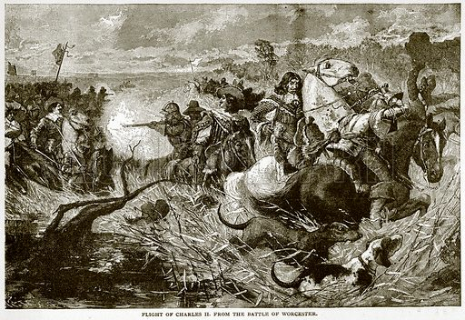
On 3rd September 1651, after the Battle of Worcester, Charles II returned to his lodgings at the building now known as King Charles II Public House. As Cromwell’s Parliamentary forces arrived, he escaped through the back door and fled the city via St. Martin’s Gate to the North of the City.
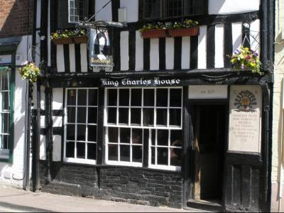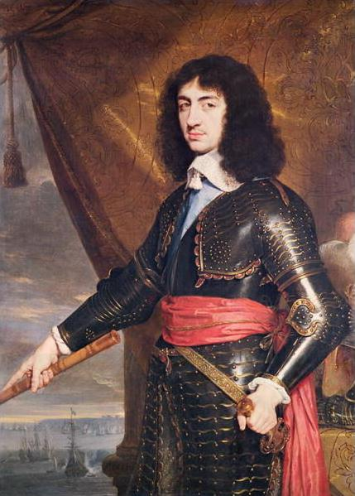
At this point night was falling, he had no shelter and needed the support of his small band of loyal officers.
Earliest written accounts mention Kinver Heath near Kidderminster and Stourbridge. The group made their way to a night’s safety at White Ladies Priory where he was disguised as a farm labourer and taught to speak with a local labourer’s accent. Having hidden in local woodland, Charles stopped at several other safe houses until late in the evening of the 7th September, riding an old horse that had been provided by the local miller, Charles continued his journey. At one point when the horse stumbled, Humphrey Pendrell who was accompanying the King commented ‘it is not to be wondered at, for it had the weight of three kingdoms on its back’.
Charles arrived that night at Moseley Hall where he was hurriedly secreted by the owner, Thomas Whitgreave, in a priest hole when Parliamentary troops arrived. The troops accused Whitgreave of fighting for the King at Worcester but he managed to convince them that he was too feeble to aid any Royalist fugitives and the troops departed without searching the house.
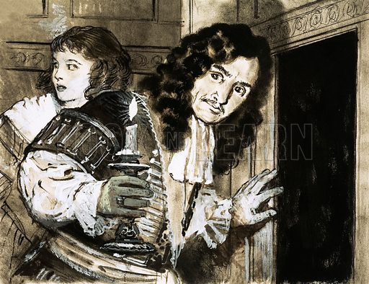
Charles flight continued for several weeks until a passage to France was secured for him. At 2am on 15th October he boarded the ‘Surprise’ which sailed on the high tide five hours later, landing at Fecamp near Le Havre on the morning of 16th October 1651.

