Milk chocolate pots with baileys cream
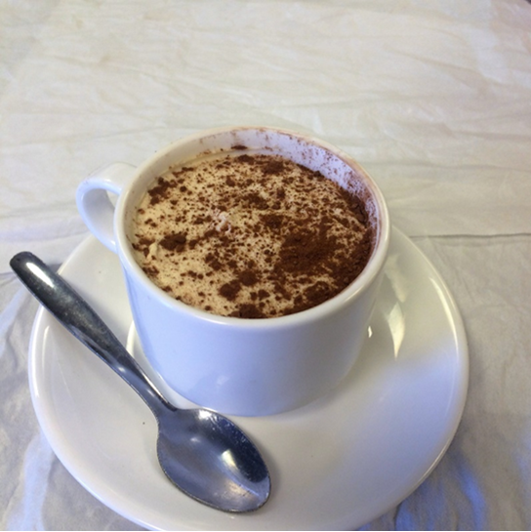
Ingredients – chocolate pot
200g milk chocolate
100g double cream
30g milk
40g butter
Ingredients – Baileys cream
100ml double cream
50ml Baileys
1 tbsp icing sugar
Method – Chocolate Pot
- Heat milk and cream in microwave until hot but not boiling
- Whisk in chocolate, cream, and butter until all chocolate has melted
- Pour into a coffee cup and allow to chill in the fridge for at least 45 minutes
Method – Baileys Cream
- Place all ingredients into a bowl and whisk until stiff
- When chocolate pot is cooled, spoon whipped Baileys cream on top and smooth over with a spoon
- Finish with cocoa powder to imitate a cappuccino

