Craft ideas inspired by Hokusai – ‘The Great Wave’
Cardboard Prints
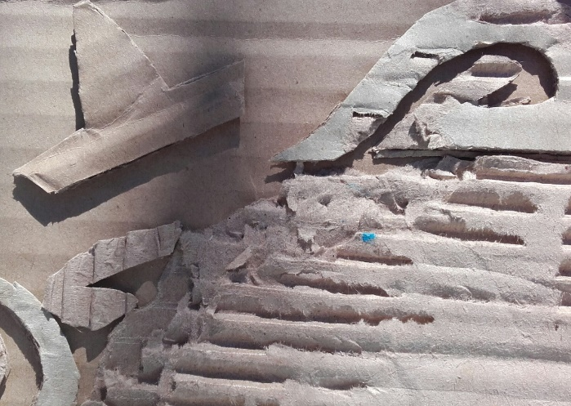
Use cut off pieces of cardboard boxes to create a base and then extra cardboard pieces to add an image. Cut shapes to depict waves, boats, flowers or anything else you specifically wish to create. Use Pritt Stick or PVA glue to fix the shapes onto the first flat layer of cardboard.
You can use a roller or just paintbrush colour directly onto the cut-out pieces. I find it easier to lay paper on top of the image and gently rub the paper on top of the area where I know I have put the paint and the surface is raised.
Printing inks work best but you can use acrylic paints. These tend to dry quickly so beware or try to work quickly to avoid producing a poor-quality print.
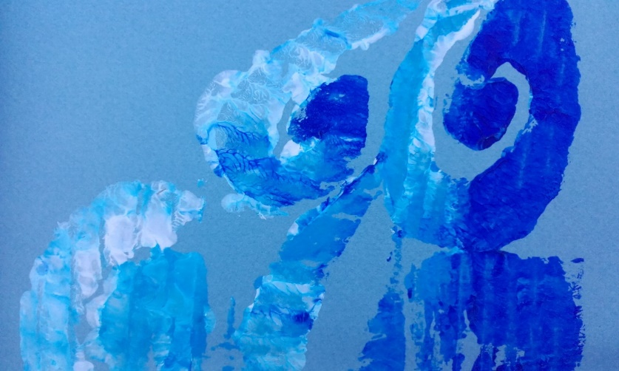
This image was inspired by Hokusai – ‘The Great Wave’
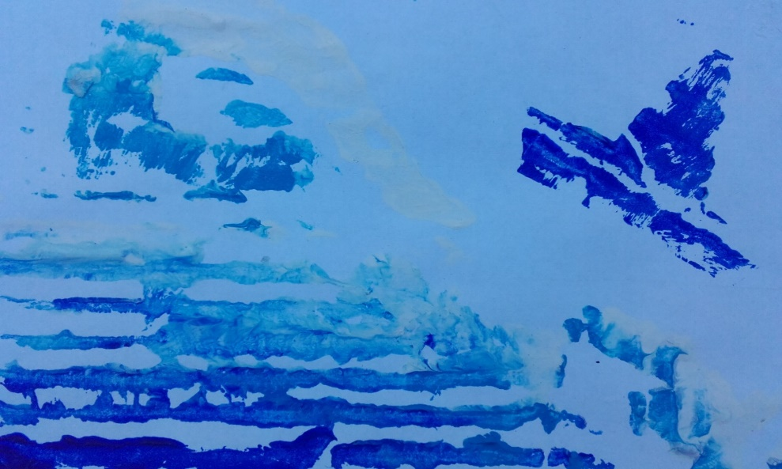
Sometimes a simpler image can be very effective.

Potato Prints
For a bit of fun when you can’t access lino or other printing medium why not try some potato printing? Cut shapes in potatoes to emulate wave patterns or spirals.
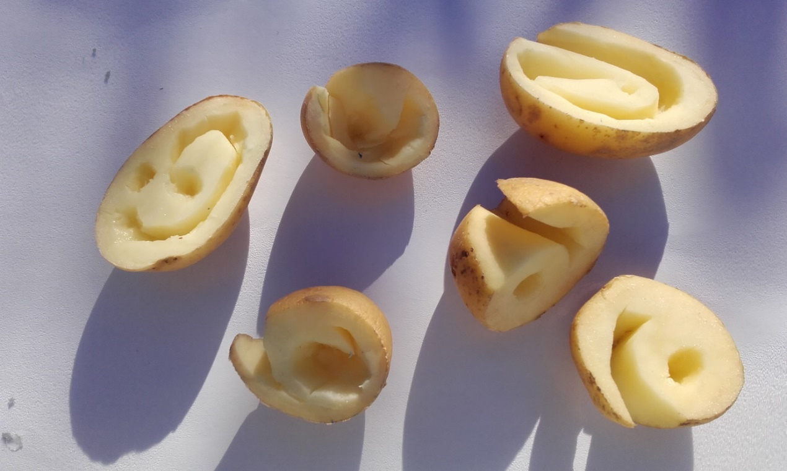
Use your prints to make gift wrap, greetings cards or decorate gift bags..
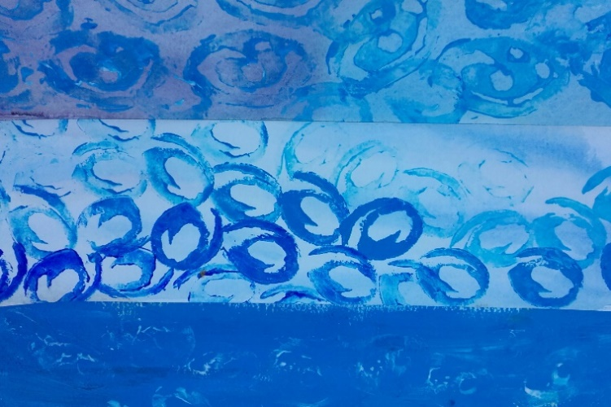
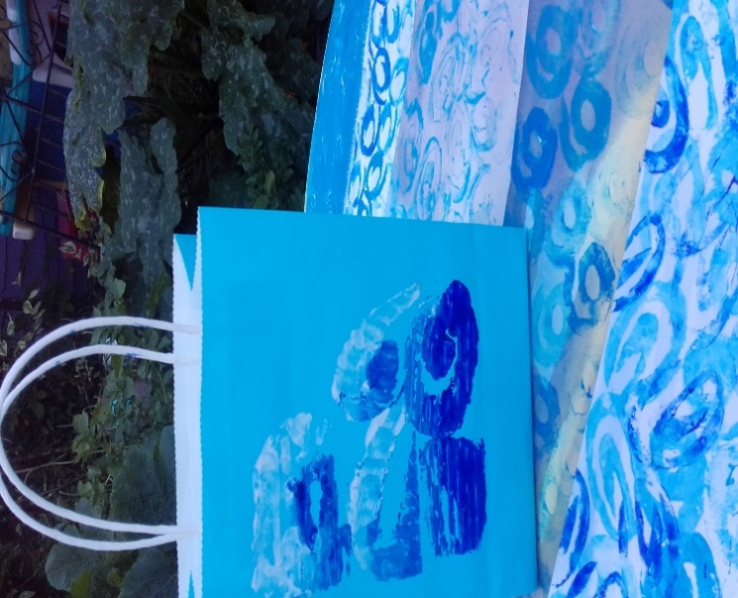

Wax Resist
Use a candle to draw abstract wave shapes onto paper.
Mix a variety of blue hues with watercolour or watered down acrylics and paint as a wash over the wax waves.
You can enhance the images by working into them with coloured pencils or fibre tips. Try adding Zentangle type patterns in amongst the waves. This is reminiscent of blue willow pattern china. For information on zentangle see article in the Mayflower resource pages:
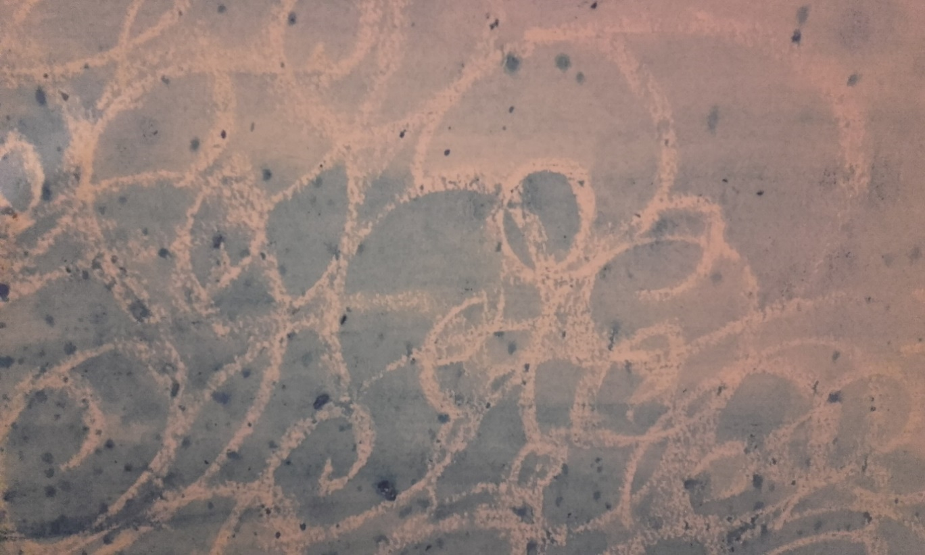
www.strichards.org.uk/live-well/living-well-resources-mayflower-theme




