Croome and ‘Capability’ Brown
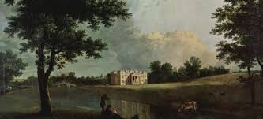
The parklands and gardens at Croome near High Green, Worcester were the very first to be redesigned by the renowned landscape architect, Lancelot ‘Capability’ Brown. Brown was appointed by the 6th Earl of Coventry in 1751 and continued to work at the estate over a period of 20 years.
‘Capability’ Brown was able to call on his skills as a landscape designer, water engineer and architect by creating a large lake on the estate, the parklands were planted with shrubs, groves and woodland as was the fashion in the day. Winding paths provided lovely views across the parkland, the house, natural landscapes and garden buildings.
From the map below, you will see the plan of Croome in 1796 upon completion of Brown’s work.
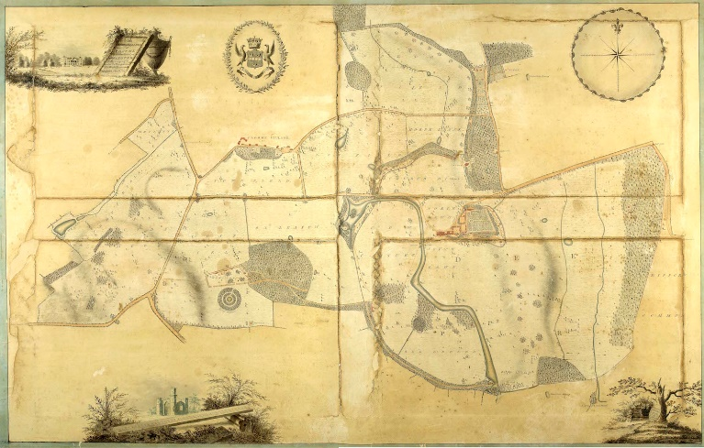
Croome saw many changes over the following 2 centuries and sadly the gardens so beautifully and painstakingly designed and built by ‘Capability’ Brown fell into disrepair following the Second World War.
In 1996 The National Trust purchased the landscape park at Croome and thereafter time was spent researching the history of the park from the archives in order to restore it back to ‘Capability ‘Brown’s original plans, replanting varieties of trees and shrubs once found there.
Ongoing work by the team at Croome is restoring Brown’s masterpiece to its former glory using, remarkably, old designs by him, the individual plants used, even placing tree seats in their original places thus providing an accurate representation of how ‘Capability’ Brown intended for this beautiful park to look when it was first created in the 18th century.
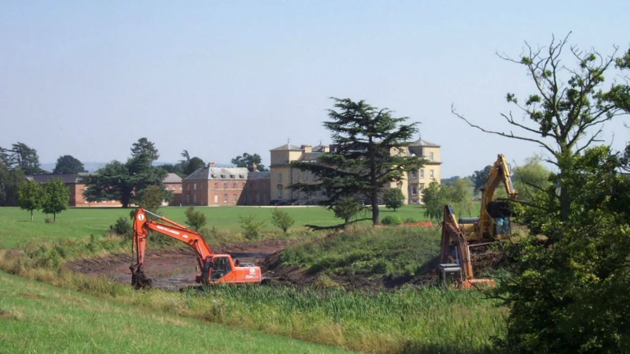
Just over half of the vast estate has now been restored which gives the feeling of recreating history and seeing Croome re-emerge as it once did for ‘Capability’ Brown and the 6th Earl of Coventry when it was first completed.
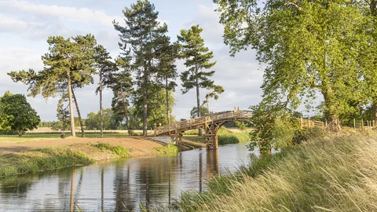

Did you know?
Lancelot ‘Capability’ Brown also designed a further 18 landscapes which are currently owned or managed by The National Trust.

Read more: www.nationaltrust.org.uk/features/restoring-the-estate-at-croome-a-capability-brown-masterpiece

Picture credits:

No.1 – Richard Wilson’s painting of the Chinese Bridge at Croome, Worcestershire. Taken from the National Trust website: www.nationaltrust.org.uk/features/lost-chinese-bridge-returns-to-croome

No.2 - John Snape’s 1796 map of Croome Park, www.capabilitybrown.org/garden/croome

No.3 – Dredging silt and reed from Croome river in 2003, Martin Barnett. Taken from the National Trust website: www.nationaltrust.org.uk/features/restoring-the-estate-at-croome-a-capability-brown-masterpiece

No.4 – The Chinese Bridge at Croome, Worcestershire, National Trust Images/James Dobson. Taken from the National Trust website: www.nationaltrust.org.uk/features/lost-chinese-bridge-returns-to-croome

