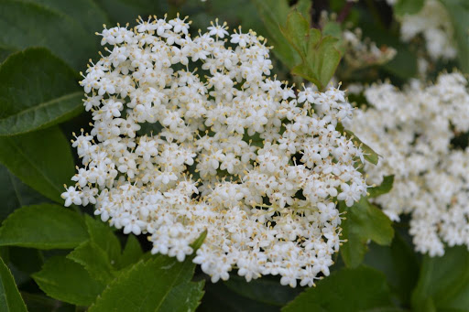
Elderflower vinegar
Great for salads and salad dressings

Ingredients
600ml wine vinegar
Five elderflower blossoms

Instructions
- Put the cold vinegar into a stainless-steel saucepan with the elderflower.
- Warm them together gently until just hot, do not boil.
- Leave the vinegar to cool then strain the liquid and put back into its bottle.

Simple but lovely.

Elderflower cordial

Ingredients
10 elderflower heads
900g sugar
Finely grated zest and juice of one organic lemon
45g citric acid

Instructions
- Pick the elderflower while they are dry, shake well in case there are any insects!
- Bring 600ml of water to the boil in a stainless-steel saucepan and add the sugar and stir to dissolve.
- Remove from the heat and leave to cool for 10 mins.
- Add the elderflowers and stir then add the lemon zest and juice and then the citric acid, cover and leave overnight.
- Next day pour the syrup through a sieve and pour into clean bottles and store in the fridge or a cool place.
- Dilute with water using one part cordial to six parts water or can be added to sparkling wine!

Enjoy!

