Garden plants and aromatherapy

Most of us will be familiar with the herbs and spices we grow in the garden, plant in wooden baskets or those sitting in delightful little pots on the kitchen window ledge.

Whilst they are widely used in culinary dishes and beverages, all of them serve another purpose in the fascinating world of aromatherapy as essential oils. We hope to be able to give you an insight into their therapeutic uses.

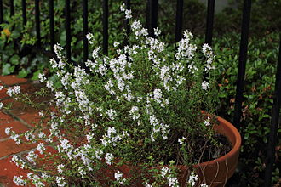
THYME:
Culinary use - soups or casseroles, great with chicken and Mediterranean vegetables, marinades.

Therapeutic use – improves memory, uplifting, beneficial to the immune system, eases joint pain, provides respiratory support, stimulates the digestive system – increases positive feelings and self-belief.

SWEET MARJORAM
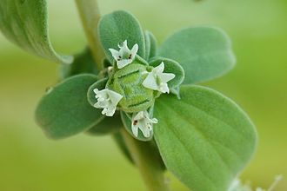
Culinary use - seasoning soups, stews, dressings, sauces, herbal tea.

Therapeutic use – calms the nervous system, helps in times of stress and anxiety, improves circulation, helps with joint pains, good for respiratory issues, soothes the digestive system – a relaxing and comforting oil.

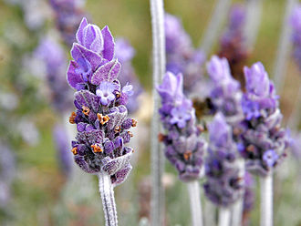
LAVENDER

Culinary use – shortbread, flavouring for ice cream or custard, sprinkle on lamb or oily fish.

Therapeutic use – gives relief to areas of pain, excellent for respiratory problems, relieves nausea, vomiting and flatulence, calms the central nervous system, promotes sleep.

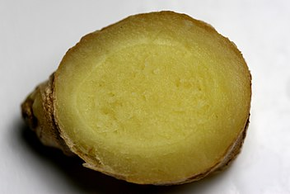
GINGER

Culinary use – pickled in vinegar or sherry, ginger beer, ginger ale, herbal teas, flavouring for seafood, meat and vegetarian dishes, gingerbread, cookies, crystallised ginger.
Therapeutic uses – good for fatigue, relieves aches and pains, eases respiratory congestion, support digestive system, warming and uplifting.

LEMON

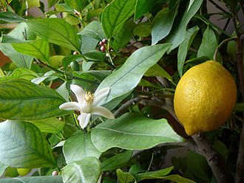
Culinary use - lemonade, salad garnish, zest used in cakes, marinade for fish, topping for pancakes, short term preservative for apples, bananas and avocados.

Therapeutic uses – supports circulatory system, reduces aches and pains, congestion relief, liver cleansing, uplifting and helps to bring balance.

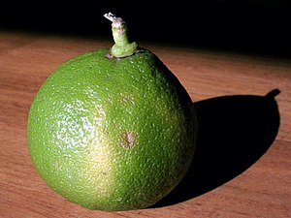
BERGAMOT

Culinary use - flavouring for Earl Grey and Lady Grey Teas, confectionary such as Turkish Delight, marmalade, liqueur, sweet candy.

Therapeutic uses – refreshing, relieves anxiety, depression and nervous tension, supports digestive system, relaxes the mind and lifts the spirits.

BASIL

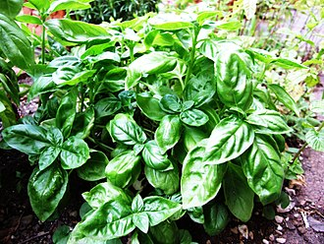
Culinary use – Mediterranean dishes (pasta and tomato), pesto sauce, salads.

Therapeutic uses – releases pent up emotions, circulatory support, muscular pain, relieves respiratory congestion, uplifting and also calming.

ROSEMARY

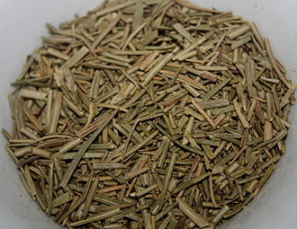
Culinary use – Italian style soups, stews, braises and lamb dishes

Therapeutic uses – good for memory and concentration, good for circulation, eases joint pain, boosts morale and self-confidence.

MANDARIN

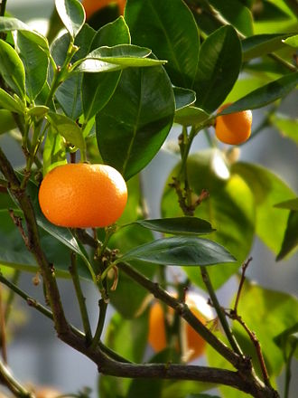
Culinary use – salads and desserts, fresh mandarin juice, oil used for flavouring in candies, ice cream, chewing gum and liqueurs, dried peel/zest used as seasoning.

Therapeutic uses – calms restlessness, helps with insomnia, reduces muscle spasm, alleviates digestive disorders, helping to deal with anxiety and depression.

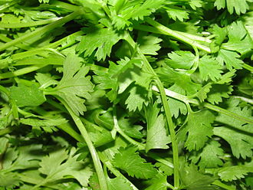
CORIANDER

Culinary use – Indian dishes, use seeds for pickling or ground into curry pastes.

Therapeutic uses – supports mental fatigue, reduces digestive issues, calming and uplifting, useful in cases of shock and nervous exhaustion, gives feelings of stability and security.

LEMONGRASS

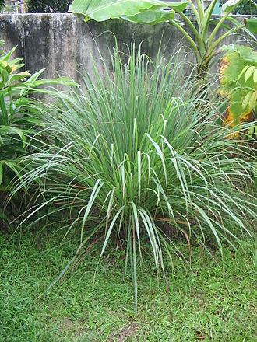
Culinary use – Thai dishes, stews and curries, stir fries, cocktails.

Therapeutic uses – lifts when feeling fatigued, reduces inflammation of muscles, good for respiratory infections, stimulates digestive system.

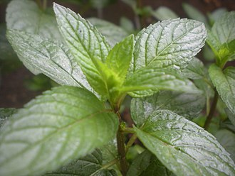
PEPPERMINT

Culinary use - for chocolate such as After Eight Mints and sweets such as Imperial Mints, herbal tea, ice cream, alcoholic beverages, fruit preserves.

Therapeutic uses – ideal for mental fatigue, supports circulatory system, good for arthritis, rheumatism, aches and pains, provides respiratory support, reduces digestive disorders.

