Highcliffe beach, Dorset
Wonderful all year round.
It is a pebbly and sandy beach with views across to Christchurch and Hengistbury Head to the west and to the Isle of Wight and the Needles to the east.
This part of the beach is between the Crow’s Nest and Highcliffe Castle and has been sectioned off by groynes. Some sections of the water are for water sports and some for swimmers. There is no commercialisation of this beach.
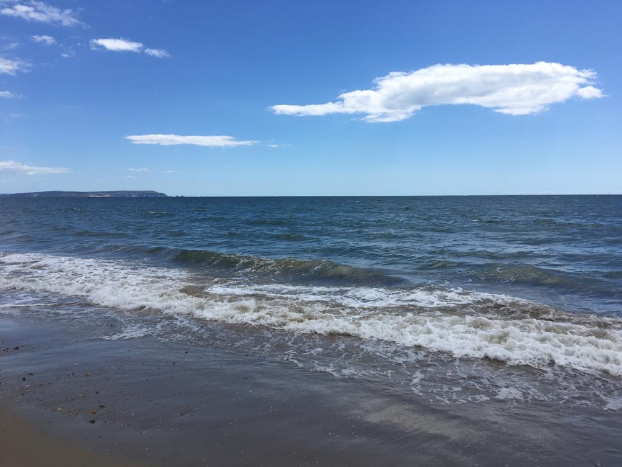

The beach itself is generally very quiet. Dogs are allowed on the beach all year round whereas further west on the more touristy beach dogs aren’t allowed in the summer months.
I love this part of the Dorset coast all year round. In the winter months it is windy and wild. In the summer it remains wild and untouched by most tourists. The children can build sandcastle kingdoms, collect pebbles and shells in their buckets (leaving them behind when we leave) and splash around in the water all year round. On the horizon on a clear day you can see cruise ships and tanker sailing to and from Southampton. Sailing boats are often seen sailing around the Isle of Wight and to and from Christchurch Bay.
As a teenager, I was very lucky to live a 30-minute walk away with my family. Now I take my children there at regular intervals throughout the year.

