KATSUSHIKA HOKUSAI - 1760 – 1849
Hokusai was a Japanese artist, ukiyo-e painter and printmaker of the Edo period. Born in Edo (now Tokyo) Hokusai is best known as author of the woodblock print series ‘thirty-six views of Mount Fuji’ and also for the iconic image ‘The Great Wave Off Kanagawa’.
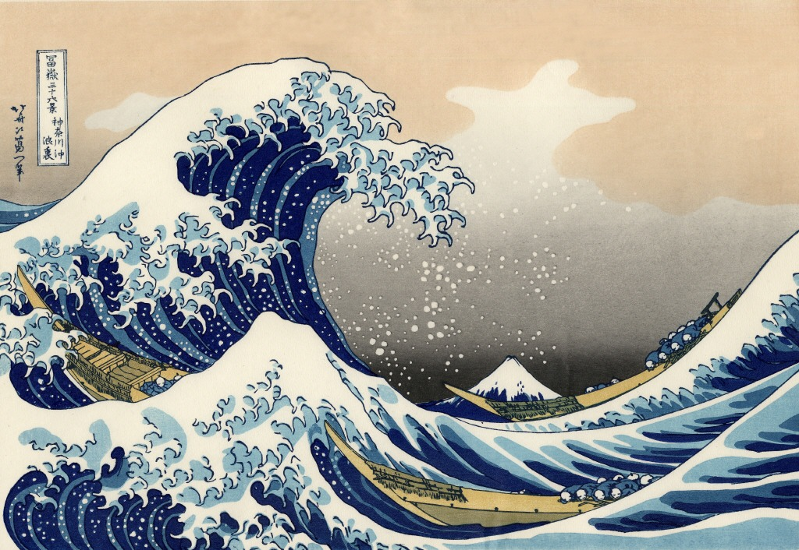

Hokusai called himself ‘Old Man Crazy to Paint’ and made his best work in his 70’s. ‘The Great Wave’ woodblock was not produced until 60 years after he first started creating art. The illustration of a crashing wave, three boats and the peak of Mount Fuji was just one of the 36-piece series ‘Thirty-six Views of Mount Fuji’. A series which led Hokusai to be a leading artist in the shaping of the Impressionist Movement in Europe.
Hokusai was much revered by the Impressionists and Claude Monet owned more than 20 of his prints.
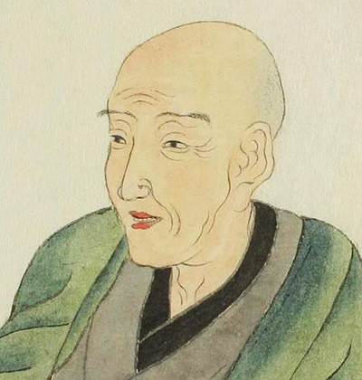

A common practice of Japanese artists during his time was the regular changing of name – Hokusai gave himself a new pseudonym every few years. The name Katsushika Hokusai however he kept for half a century. ‘Katsushika’ refers to the part of Edo (former Tokyo until 1868) where he was born. ‘Hokusai’ meaning ‘north studio’.
Hokusai supposedly did not like to clean and moved over 90 times in his life; letting his various abodes build up with dirt before becoming unbearable; forcing him to vacate and move on!
During his life Hokusai suffered a series of personal setbacks. Both his wives and his children died before him and at 50 he survived a lightning strike. During his 60’s he suffered a stroke which led to him requiring to re learn his art. The series of dire events led Hokusai to turn to his greatest passion and he began working on the famous series ‘Thirty-Six Views of Mount Fuji’.
Hokusai once stated that the views of Mount Fuji, the highest mountain in Japan were his source of ‘the secret of immortality’. From a folk tale he suggests that the entire secret of eternal life was given to this volcano, which continued to produce smoke filled with answers till the end of time; therefor remaining alive forever! This reflected his own understanding of the relationship with immortality. Hokusai once reflected that ‘…when I reach 100 years I will have achieved a divine state in my art and at 110, every dot and every stroke will be thought alive’.
When the Great Wave was first issued in the 1830’s Japan’s contact with other countries was strictly regulated. It was not until 1859, under pressure from USA and other powers that Japan opened a few of its ports and Japanese prints began to be exported to Europe. They were quickly discovered and revered by artists such as Monet, Van Gogh, Toulouse Lautrec and Whistler. The Great Wave also inspired Debussy’s symphonic sketches ‘La Mer’.

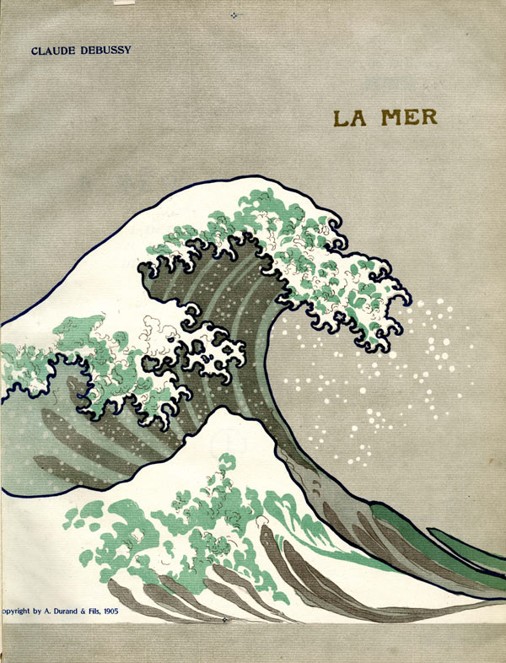
‘The Great Wave’ became one of the most iconic images of the power of the sea.
One of the most celebrated contemporary paintings using The Great Wave as inspiration is ‘Michael and I are just slipping down the pub for a minute’ by LIN ONUS in 1992. The image depicts a dog sitting on a sea creature, surfing on Hokusai’s Great Wave.
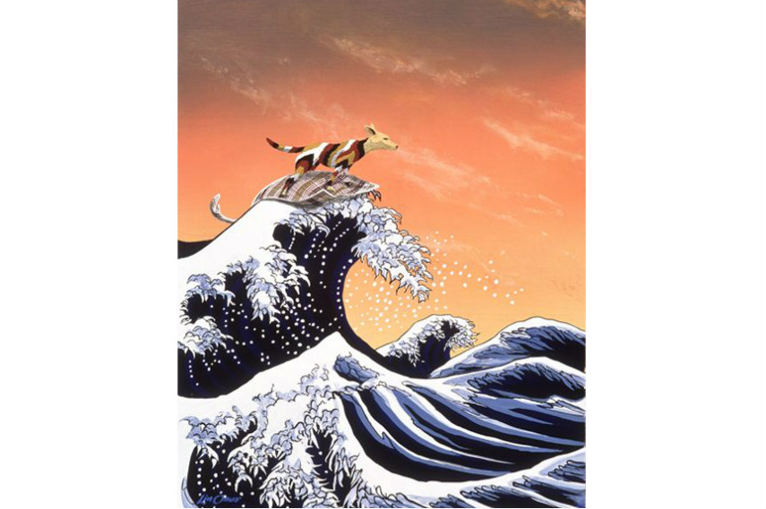

The artist KOZYNDAN created a digital image in 2003 where he replaced the foam from the wave with bunnies! 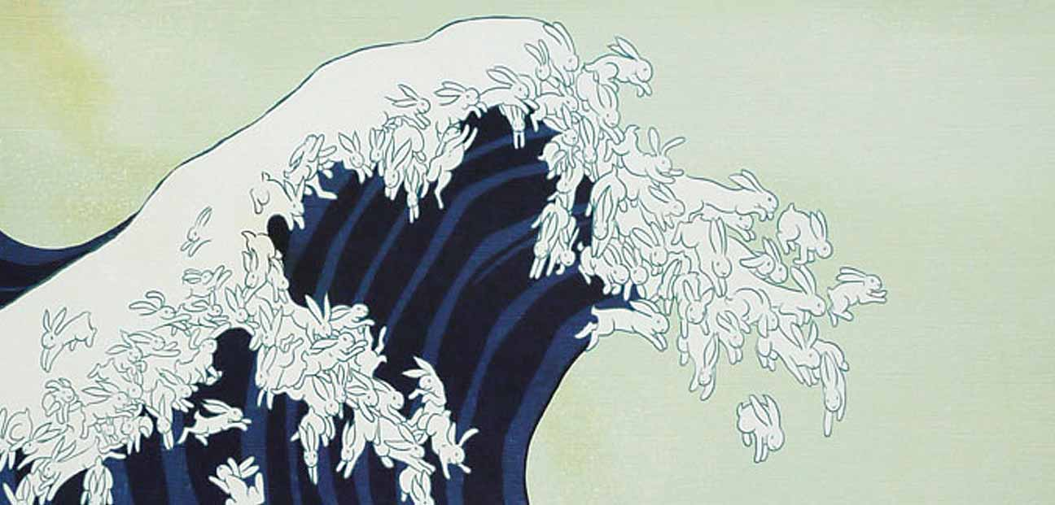
The iconic image is present everywhere, from postcards in Japan to clothing, kitchenware and even used by graffiti artists to stamp an image on walls. Spanish street artist PEJAC reinterpreted the image as a tribute to working women of Japan by painting the wave coming out of a bucket of a cleaning lady.

