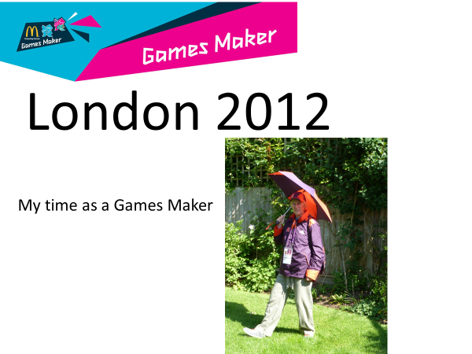
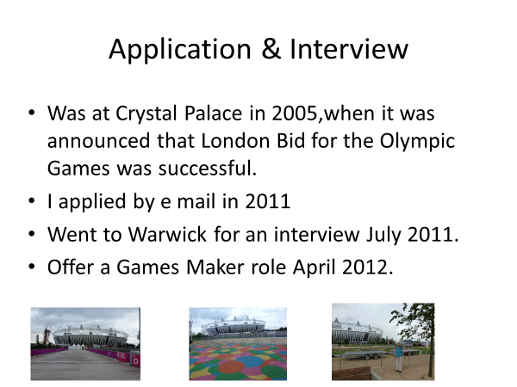
I had to go up to London three times for two training sessions, one of which we were shown around the Olympic park before it opened and another time to collect my uniform.
I was to join the Entertainment Team which was based at Eaton Manor, north of the Olympic park, and later the venue for the Paralympic tennis.
We had to complete 10 shifts of either 8am-4pm or 2pm-10am, with two rest days. My first shift was on day one – 28th July at 8am! I was able to stay with my son in north London.
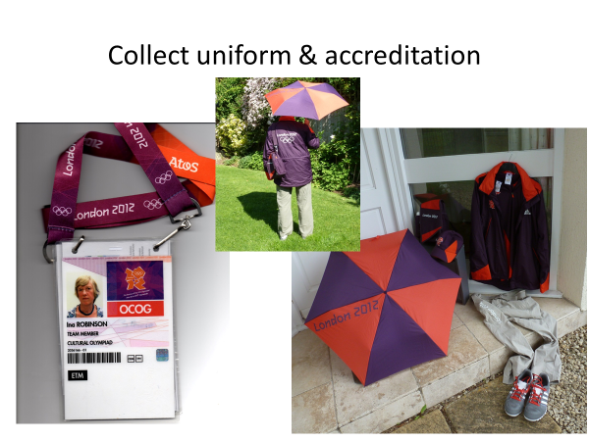
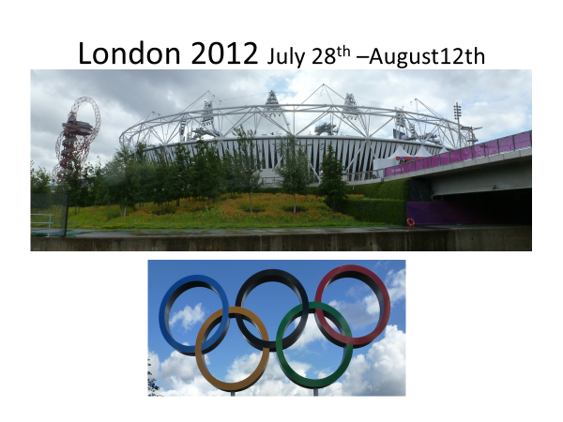

Each morning there was a briefing when we were told what ‘talent’ we were expected to chaperone that day. We would then meet them at the entrance and take them to ‘back of house’ make sure they had the necessary equipment, microphones, staging, umbrella, water, lunch, etc.
After loading a trolley, we would venture out into the park dodging all the crowds to get to our assigned ‘pitch’

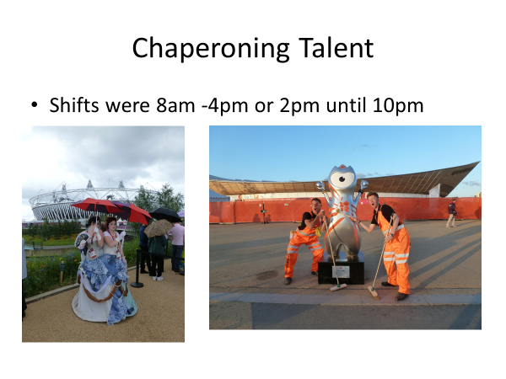
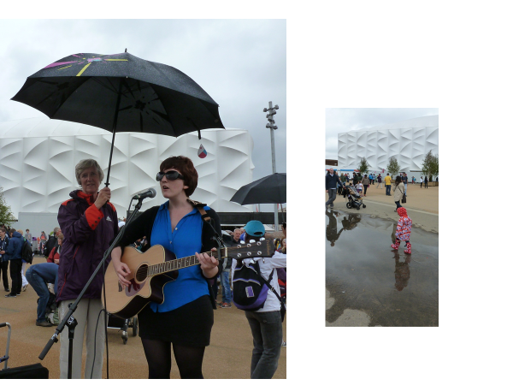
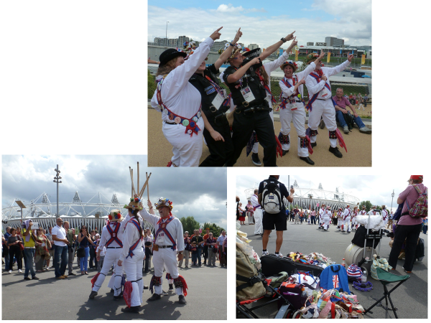
Every day was different. You could have one young person playing a guitar, or a group of entertainers. There was a lively group from Rio to promote the 2016 games. I chaperoned morris dancers and drama students.
Sometimes we would go out for ‘walk about’ with Wenlock the Olympic mascot. He was only allowed out for half an hour, as he got too hot, but the children loved him.
The atmosphere in the Park was tremendous everyone was enjoying themselves and the Games Makers added to the carnival spirit. I am so glad that I volunteered and was able to be one of them.
I have already applied to join the team for the Commonwealth Games in Birmingham in 2022.
