The Mariana Trench – the deepest part of the ocean
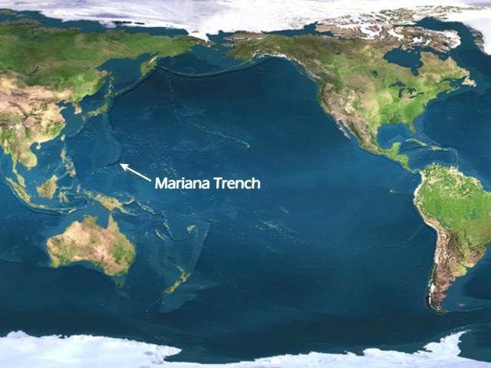
The Mariana Trench is located in the western Pacific Ocean and is the deepest part of any ocean on planet earth.
It covers 1,580 miles and is a crescent shape in the crust of the earth. What is impressive is not the length of the Mariana Trench, but its incredible depth therefore it has not been well explored because of the challenges for any craft to go so deep. It is thought to be at 36,070 feet in depth.
The facts:
- The Mariana Trench is deeper than the highest mountain in the world. If Mount Everest was placed at the bottom of the Mariana Trench, its peak would still be more than a mile under water.

- It is believed that the Trench could be well over 180 million years old and one of the most ancient sea beds on the planet.

- Due to its sheer depth, light does not reach the bottom and whilst the conditions are very acidic, interestingly enough micro-organisms do exist there such as crustaceans and amphipods. Perhaps in time, when further expeditions explore the depths, the Mariana Trench may reveal new species previously undiscovered.
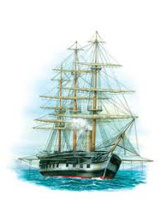
- The Mariana Trench was first discovered in 1875 during the HMS Challenger Expedition; a circumnavigation of the globe. The expedition was a forerunner in the field of oceanography, exploring and mapping the oceans travelling nearly 70,000 nautical miles. The trench was found by sounding equipment on HMS Challenger and was named after the nearby Mariana Islands.

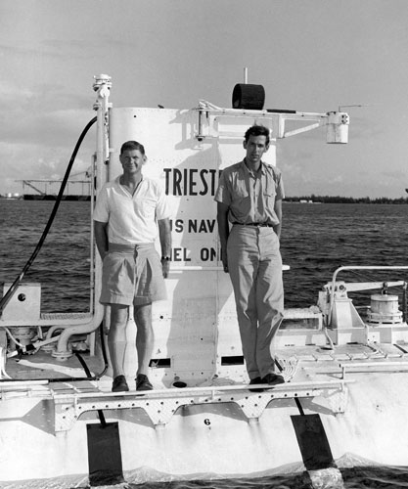
- There are areas of the trench which are deeper than others. The deepest is called Challenger Deep and was named after the two ships which explored it with sounding equipment: HMS Challenger and HMS Challenger Two. The latter explored the Mariana Trench 76 years after HMS Challenger.

- Two gentlemen earned the distinction of being the first people to reach the Challenger Deep in January 1960. Scientist Jacques Piccard and US Navy Lieutenant Don Walsh were on board the submersible Trieste when it made the descent to the ocean floor which lasted for approximately 20 minutes before they ascended to the surface.

- Although the temperature in the depths of the Mariana Trench ranges between 34-39°F, because it is not reached by sunlight, surprisingly the water can get hot from hydrothermal vents along the trench and can reach 700°F. The water from these vents releases minerals which sustain the organisms which live there.

- In March 2012, the Hollywood film director James Cameron piloted Deepsea Challenger (DCV 1) on a solo dive where he took the submersible to the bottom of the Mariana Trench spending three hours exploring the Challenger Deep at a depth of 35,756 feet.
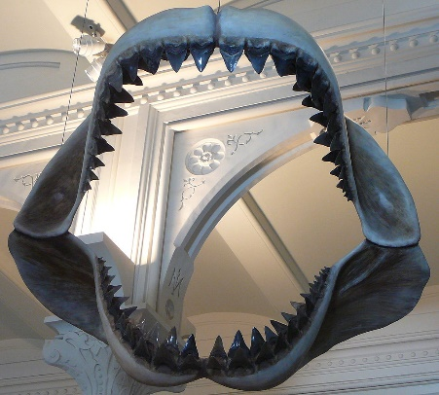
- For many years people have been mystified by the Mariana Trench, what creatures live down there and inspired Author Steven Alten to write his book Meg purportedly an extinct predator of 20 tons, the Carcharodon Megalodon.

- In 2009, the incumbent President of the United States, George W Bush, signed the act naming the Mariana Trench as a national monument.
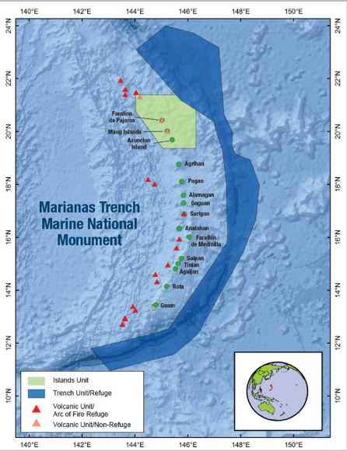
- To date, four manned descents and three unmanned descents have been achieved with new species being discovered: tiny organisms, gigantic single-celled amoebas and snailfish. As technology advances, more areas of the Mariana Trench may be explored and further discoveries made.

