King Charles II
Public House Worcester

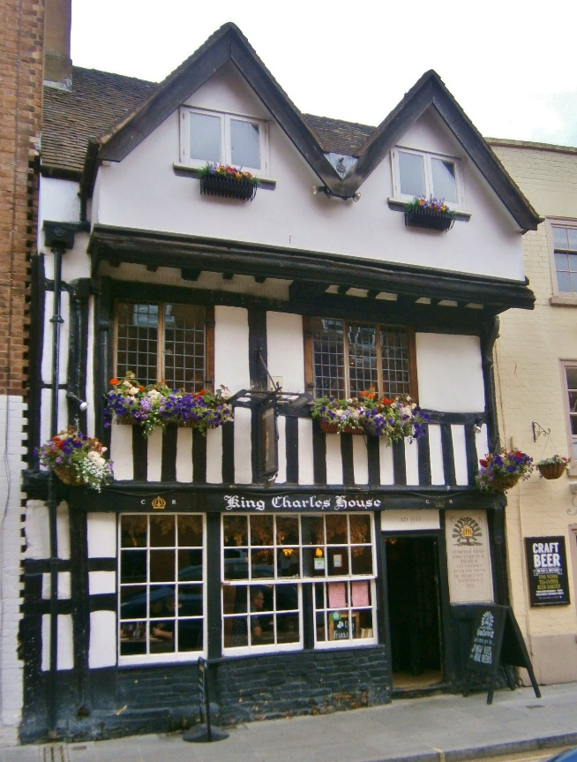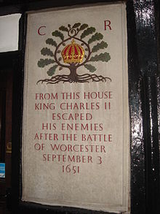

The King Charles is the most historical of the local Craddock’s Brewery pubs. The pub on New Street is a black and white listed building in the heart of the historic city of Worcester.
It was through this pub that King Charles II is believed to have escaped after losing the final Battle of Worcester in 1651. The residents of New Street held off Cromwell’s army so he could make his escape from the house.
The pub has since been a judge’s residence, an antiques shop and a restaurant. It has been the home pub of Craddock’s ales in Worcester since 2013 and is renowned currently for its pies and pints, having an extensive menu of unusually named pies. The bar has a great range of real ales and local ciders.
Be sure to check out the skeleton in the oubliette and the roller coaster ride which is the first floor! There is a piano on the first floor for passing musicians and a comfy seating area with books and board games. The pub is known for its oak-clad walls, roaring fires and dungeon!

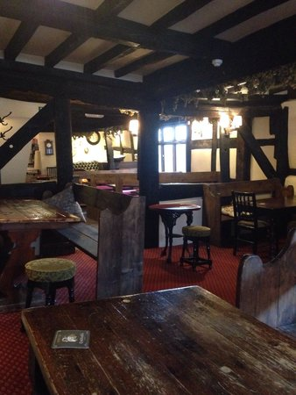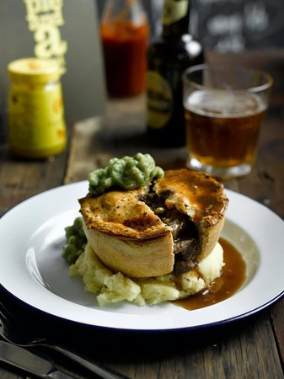

The King Charles currently holds a quiz on Tuesday nights and a board games session on Wednesday nights.

