Mindful Moist Mouth (MMM)
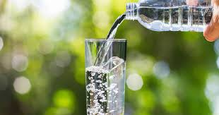
When feeling stressed or anxious, we may experience a dry mouth and by moving the tongue around the gums and gently squeezing the tip of the tongue can help to stimulate the buccal response and flow of saliva.
By sipping and holding a drop of water in your mouth it can interrupt an increasing level of anxiety.
Doing this in a mindful way introduces the means of self-soothing, slows rapid over breathing and contrasts with the discomfort of the “anxious dry mouth”.

Three steps to a Mindful Moist Mouth (MMM)
First, acknowledge that when we are anxious, our mouths can be dry but when we are calm our mouths are moist. Therefore, moistening the mouth will support the relaxation response in your body.
Secondly, take a sip of water. Hold it for a moment and then swallow – noticing the sensation of coolness, the moisture in your mouth and throat.
Thirdly, take another larger sip; hold it there until your tongue becomes fully coated with the cool and refreshing water, noticing each and every time you do this you can become calmer and calmer.
Finally, we suggest you carry a bottle of water with you, sipping from it when you need to, taking a moment every time you use this technique to experience a calm, comfortable and relaxed state.
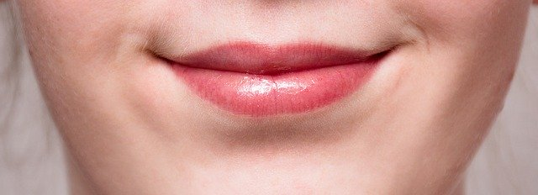
Having water to hand each day will encourage you to practice this simple technique to keep feelings of anxiety in check and maintain a sense of calm.

