

**Name the flower quiz**

Take a look at the picture clues below, and see if you can work out which flowers they represent! Answers are at the end of the quiz.

1. 
2. 
3. 
4. 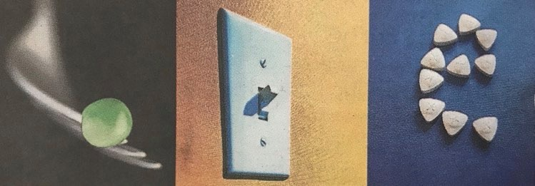
5. 
6. 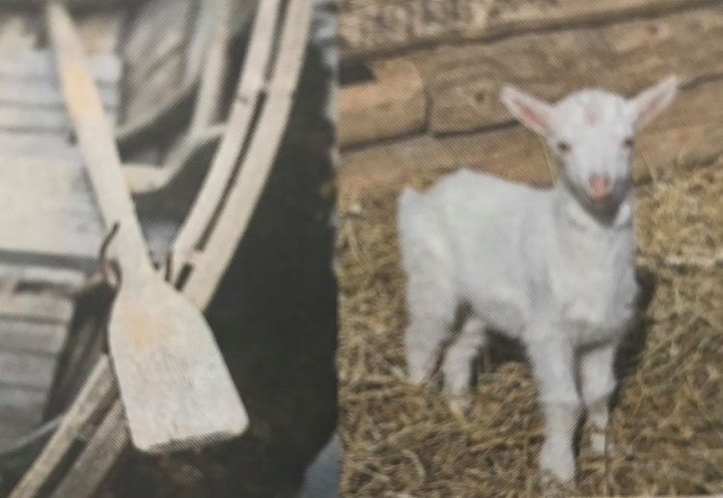
7. 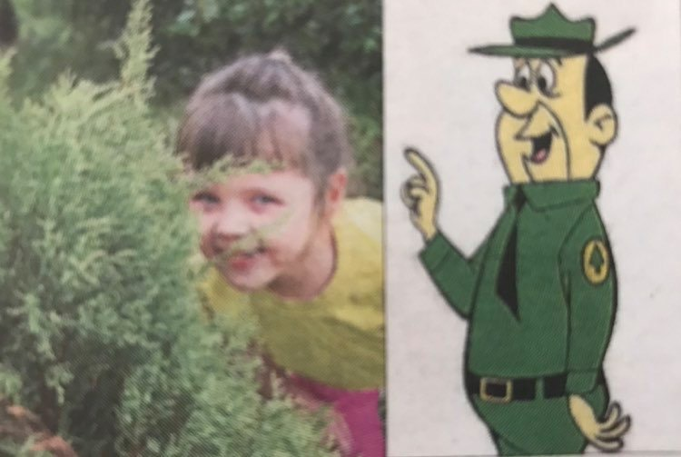
8. 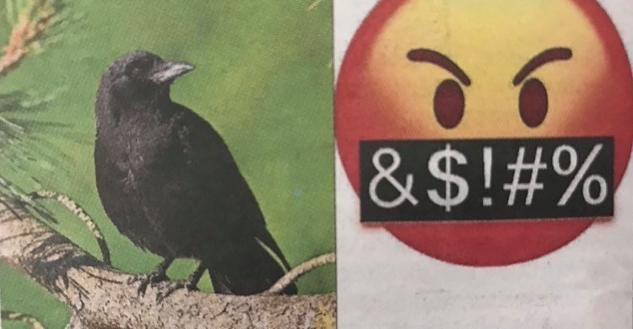

**Answers**

1. Foxglove
2. Tulips
3. Snap dragon
4. Peony
5. Pansy
6. Orchid
7. Hydrangea
8. Crocus