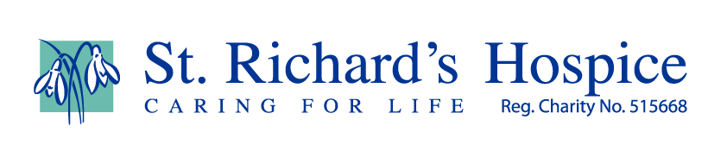

Simplifying Sport
We can use art to create simple images using a variety of styles.
Sports icons allow us to tell which sport is being depicted with just a very simple image to define individual sports.
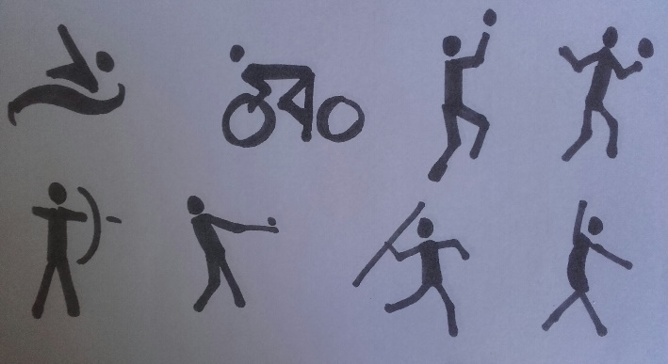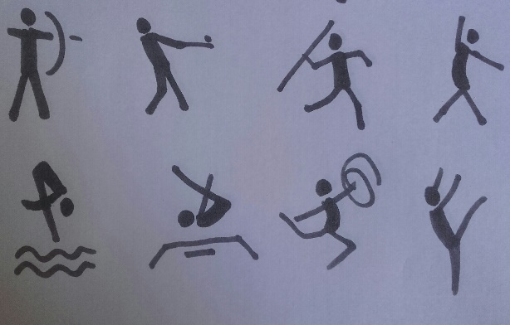
We can use simple cut out images in the style of sports icons to do this, as on the ‘famous men’ resource site where we highlight the work of Henri Matisse.
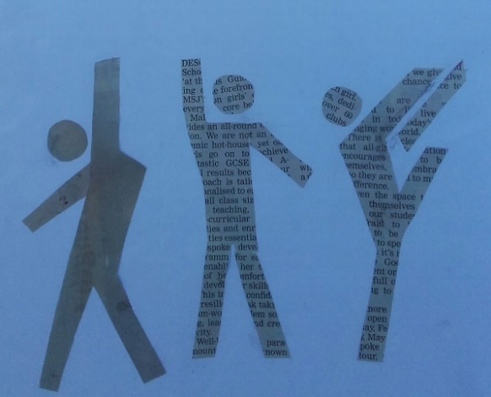
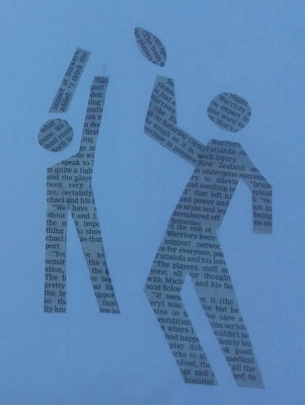
Coloured papers, newspaper or magazines can be used to cut out the images.
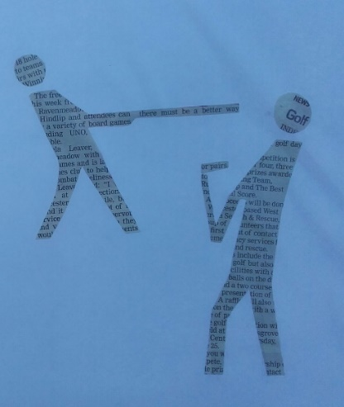

These images were made with the insides of junk mail envelopes. Note the use of the negative image in the final pieces below.
Henri Matisse used a combination of positive and negative images in his cut out artwork.
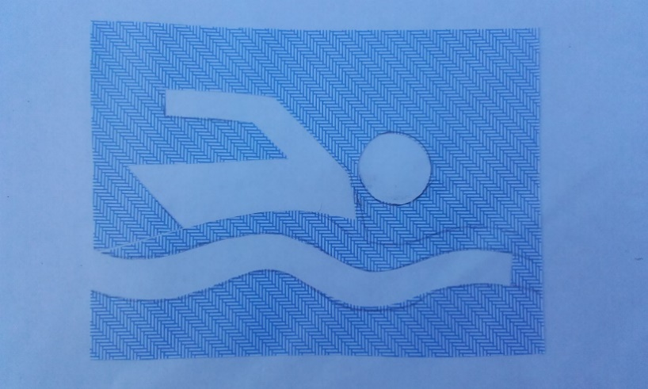
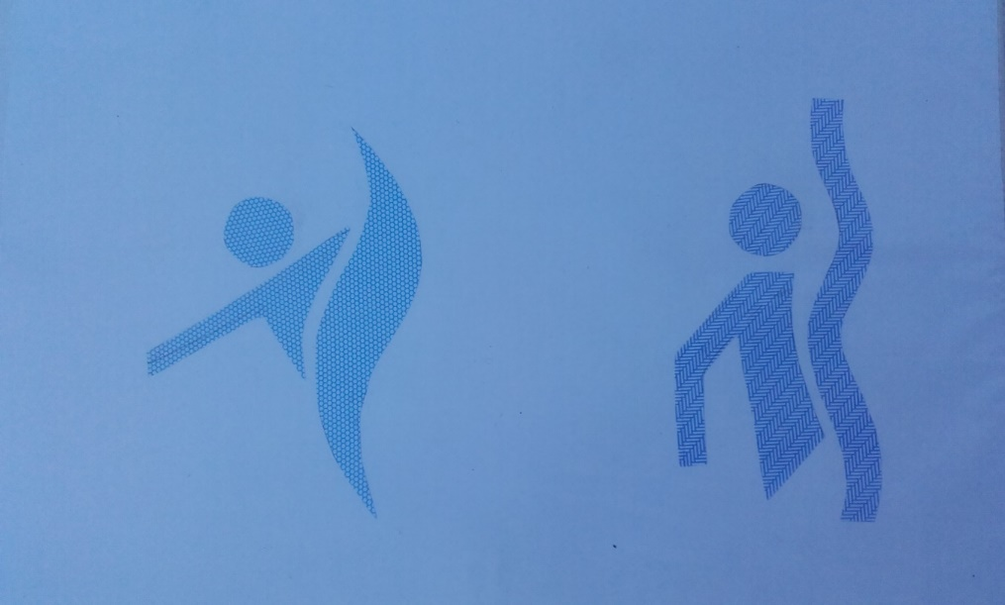

Painting simple sporting images - watercolour
Find a simplified image such as a sport icon to work from.
Mix large puddles of colour so that you can soak up the paint using a large round brush (no 10 is good) and use the paint in one good brushstroke to convey a body part or movement.
Use one bold brushstroke to paint the main body first, looking at the angle of the body as it would be if in motion in that sport. Is it straight or angled?
Next look at the position of the legs. Fill your brush with paint from your puddle of colour before each stroke and use one stroke only to paint each of the legs in the position that would depict the given sport and its movement.
Painting the legs after the body helps reinforce the position, structure and where the weigh of the body will be.
Note changes of angle where the hip meets the body and where the knees or ankles are but keep to one stroke only for fluidity.
Load the brush again for each of the arms. The arms will help define movement and balance in the body to help depict the sport.
Note the change of angle at the elbow and wrist but again use one stroke only for each arm.
Consider the position and angle of the head in relation to the rest of the body.
You may need additional strokes for sporting equipment to put your figure in context.
Once you have finished your painting you may use a second or third puddle of colour to drop into the first – this may highlight areas of weight bearing or add to intensify a movement.

Sample 1 – football: simple brushstrokes convey a simple image
Sample 2 – judo: additional thin lines (using point of same brush) reinforce movement and body position
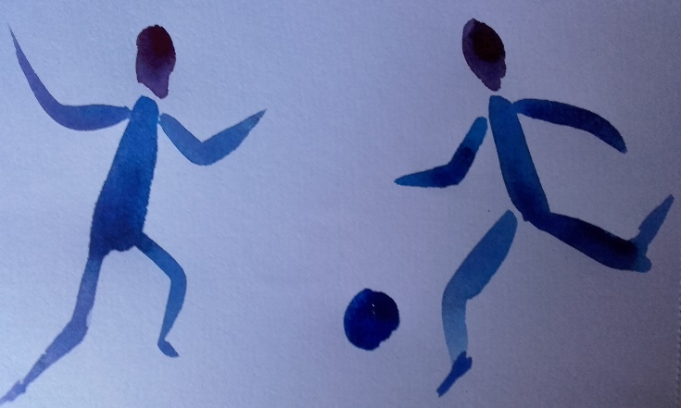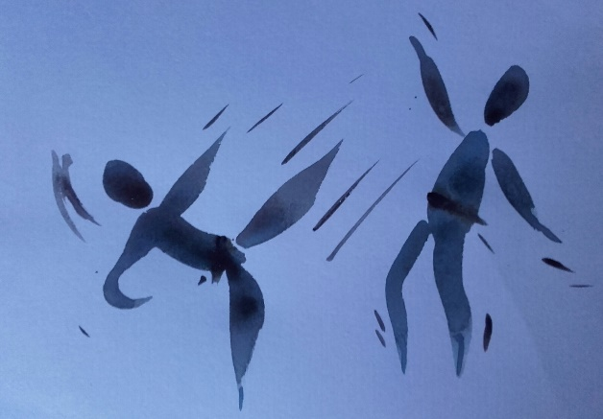

Sample 3 – gymnastics: note that paint is very wet and can run and ruin your image if moved too soon
Sample 4 – cricket: use the tip of the brush to add movement strokes or to add extra characters to a scene. The same brush can be used by gently tickling with the brush tip to create strokes
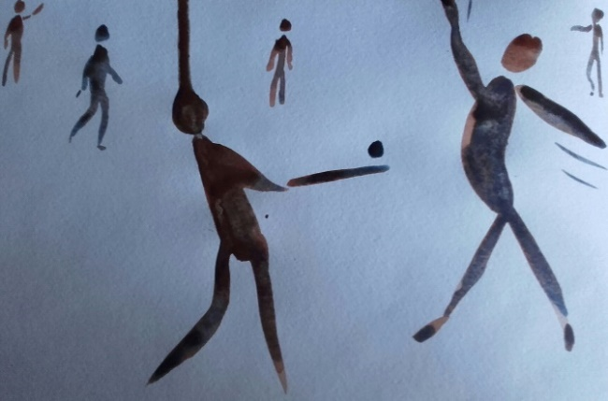
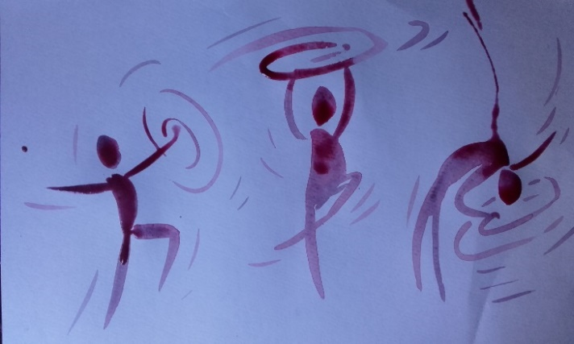

Sample 5 – rugby: several characters can create a scene. Smaller brushstrokes with point of same brush can add detail in the distance such as extra players or a spectating crowd depicted as rows of dotted heads.
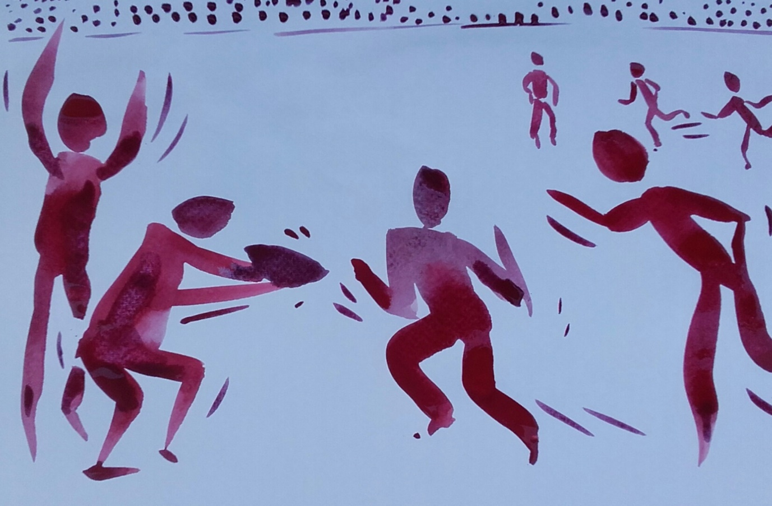

Sample 6 – skiing: emphasise position and where the weigh is distributed by position and addition of deeper hue of colour. Note base of body and top line of legs where colour is denser
Sample 7 – swimming: addition of paint splatters as well as finer strokes can help indicate movement such as splashing in water or snow blasted away from ski
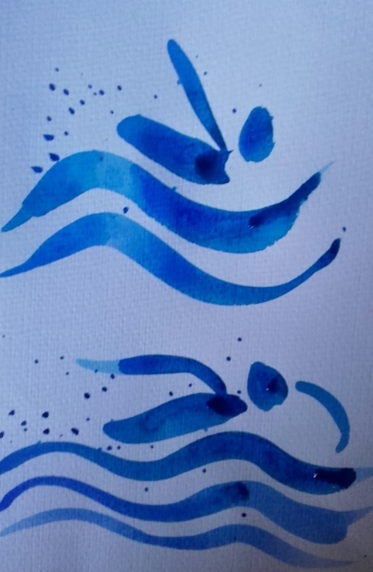

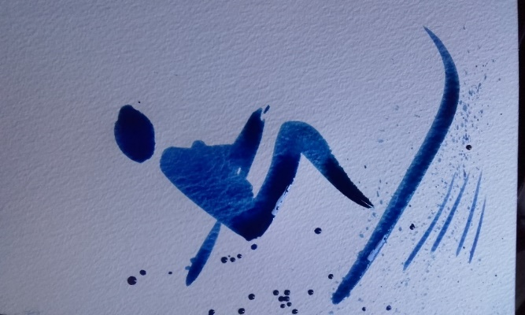

Sample 8 – basketball: use tip of brush to add equipment
Sample 9 – javelin: a smudged effect can also create atmosphere, movement and distance. Add another layer of paint on the character once the smudging has dried
