Sport and Nature

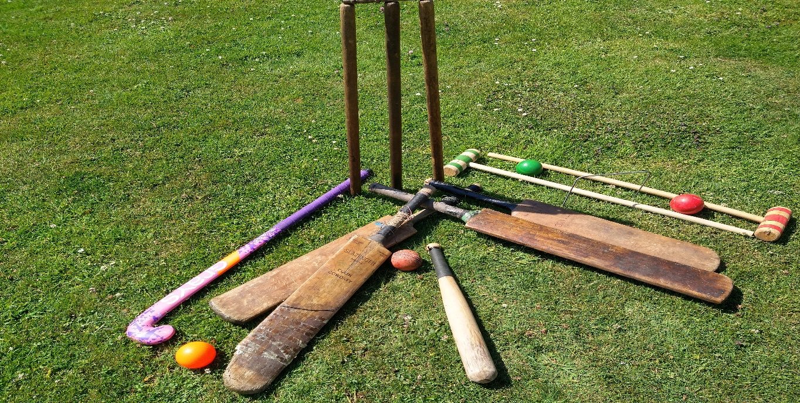
Nature and sport are almost impossible to separate. The natural environment often provides the backdrop for many sporting activities including Wimbledon and the Olympics and consequently, sports can have a direct impact on nature.
Careful thought and planning must therefore be given to the surrounding flora and fauna when planning a new sporting venue, or event.
Wood has traditionally been used in many sports to make the equipment and apparatus.
Some believe tennis may date back as far as ancient Egypt, Greece and Rome. There is some evidence that French monks were playing something similar to tennis more than 1,000 years ago.
The first wooden tennis racket recorded in Britain was made in 1874 in London by Major Walter C. Wingfield and was made of solid wood. Can you imagine the weight?! After that, a lighter version made of laminated wood was manufactured in 1947 and has developed considerably since then.
Although cricket doesn’t feature in the Olympics, it is a very popular sport in Worcestershire.
Cricket bats are a perfect example of the partnership between sport and nature. Their manufacture can be seen as an art form which has been developed and improved upon over many decades.
Traditionally, the bats have been made using a variety of English willow called cricket bat willow, or white willow (Salix Alba Caerulea), and are then carefully treated with raw linseed oil which runs into all the crevices and helps maintain moisture levels. This reduces the risk of the bat cracking or splitting.
Willow is tough, shock-resistant and springy, so perfect to meet the demands of a high speed, hard cricket ball being bowled at a speed of up to 161.3kph (100.2mph), incredible!
(Shoaib Akhtar (Pakistan), ODI v England in 2003 at Newlands)
Hockey and hockey sticks can possibly be traced back to a Native American tribe called the Mi’Kmaq, around the mid-1800s.
The sticks were originally made from birch and hornbeam trees and, according to historians, were called a Mic-Mac hockey stick. In Britain, they have traditionally been made of hickory, ash or mulberry wood and due to the curve at the head, require skilled crafts people to make them. In more recent times hockey sticks have been made from composite materials including fibreglass and carbon fibre.
Field Hockey – Rachel Walker a physiotherapist from Worcester has represented Great Britain in the Olympics.
Sports that are played indoors often use wooden flooring due to its durability and the fact that there is a great variety of wood available. Bowling alleys typically use maple or pine wood for their floor covering as do many squash and basketball courts.
There are so many sports that use wood and natural materials. Oars used in rowing, which is another Olympic sport, were traditionally made of ash and fir wood.
It’s so fascinating to learn about how much is involved in producing these items.
Hopefully this has given you some food for thought and you can perhaps do some of your own research.
Maybe you will have some happy sporting memories to share either with us, or with your friends and family.

