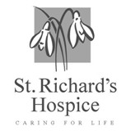
ST RICHARD’S HOSPICE
JOB DESCRIPTION

Job Title: Staff Nurse – In-Patient Unit
Responsible to: In-Patient Unit Manager/ Ward Sisters
Accountable to: Care Director
Pay Point: 10-12
Our Values:
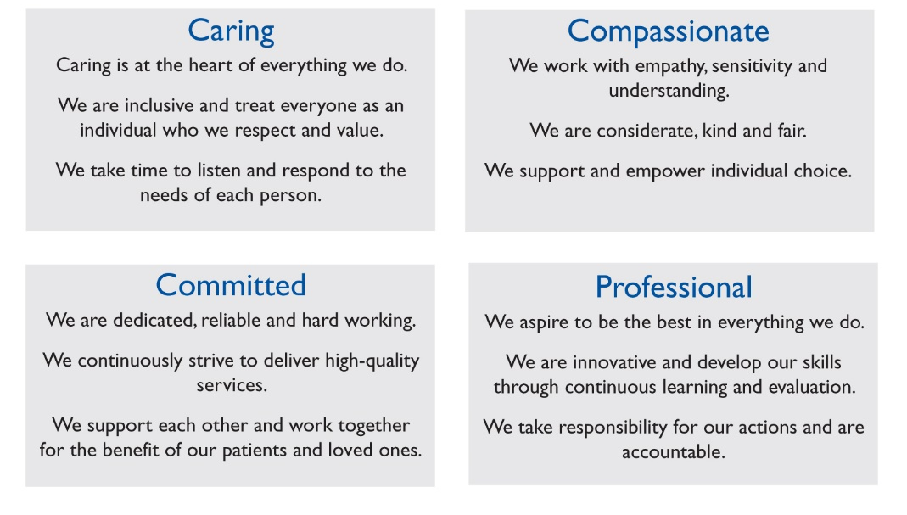
Job Summary:
- Provide a high standard of evidence based individualised patient care by the practice of systematic nursing approach
- Take charge of a shift, as required, staff allocation and task delegation, ensuring standards are met through effective use and co-ordination
- Demonstrate an understanding of hospice care and implement hospice philosophy in the clinical setting
- Through leadership and own practice, promote an appropriate environment in which to care for patients and their carers, being aware of physical, social, emotional and spiritual needs
- Work within a system of team nursing and with the wider multi-disciplinary team
- Have knowledge of and implement the agreed Hospice policies and procedures
- Participate in the effective management of the ward
- Act as a mentor to new staff and/ or students
Main Duties and Responsibilities:
Clinical Responsibilities:
- Act in accordance with the NMC Code of Professional Conduct. Ensure registration is current and manager informed
- Ensure that Hospice procedures for the administration and recording of all drugs issued to the Hospice or its patients are followed
- Observe clinical practices, procedures and standards within the Hospice and monitor and update these as necessary
- Assess, plan, implement and evaluate individual care in consultation with the patient and their carers and the multi-disciplinary team
- Ensure that the dignity, safety and wellbeing of the patient and relatives are respected at all times

Management:
- Ensure the appropriate delegation of the care of patients and other duties when in charge of the ward
- Ensure a safe, clean and pleasant environment for patients, relatives and staff
- Ensure that equipment is in good working order and report any defect immediately
- Implement health and safety, infection control and fire procedures where appropriate
- Report incidents, accidents and complaints to the Ward Sister/ Nurse in Charge, completing the relevant paperwork

Education:
- Take responsibility for individual professional development by keeping up to date with current advances in nursing practice and research, particularly in the field of palliative care
- Assist in orientation, guidance and teaching of new staff
- Support and advise other members of the team when necessary in order to promote and maintain staff morale
- Use IPR constructively for personal and professional development
- Be prepared to work towards specialist qualifications appropriate to the role
- Become a Link Nurse for an area of special interest and share expertise and practice development
- Participate in study days as requested as required by the NMC Code of Practice
- Ensure own Revalidation needs are met
Research/ Audit:
- Demonstrate a commitment to developing research/ audit skills and be receptive to the research/ audit plans of others
- Participate in appropriate research/ evaluation/ audit studies on the ward
- Demonstrate reflective and evidence based clinical practice

Safety at Work:
- Personal responsibility for safety as outlined in the Hospice Health & Safety Policy and the Health and Safety at Work Act 1974
- To report and document all accidents and incidents and be aware of and comply with fire regulations

General:
All staff are required to abide by St Richard’s Hospice policies and procedures, including confidentiality, equal opportunities and data protection.

This job description is not exhaustive and may be reviewed on agreement of the post holder and Line Manager.

Signed……………………………………………………Date………………………………..

