Sunflower Gallery
Mary, Creative Therapist with the hospice’s Living Well Team, has been involved with a sunflower project in Worcester. Read about the project, and take a look at some of the images involved.

The sunflower-themed outdoor gallery can be found on the railings of Lansdowne Park, beside the canal and nearby Arboretum residential area.
The artwork is mostly A4 pieces, sealed from the weather in poly pockets. Anyone is welcome to add to the display at any time.
Pocket Park - Westbury Gardens is a small community garden area on the opposite side of the Arboretum area. You can also find them alongside the canal, next to the railway bridge just off Rainbow Hill.
For the past two years, residents of the Arboretum have hosted a project where people light up their windows, creating a ‘window wonderland’.
It is usually held on the nearest Saturday to Valentine’s day and called 'Love the Arboretum'.
This summer, it was proposed to host a summer version encouraging residents to display sunflower artwork both outside in the parks, and inside in their windows.
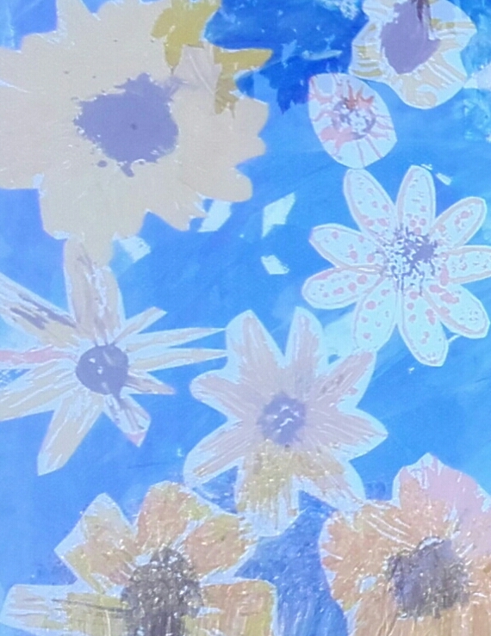
The idea is to ‘light up the Arboretum with sunflowers’, encouraging green-fingered residents to grow and display plants in front of their houses.
