Amazing Animals in The Wild
by Liesl Hopkins, Complementary Therapist
I would like to give you an insight in to my top five wild animals, all of which are most beautiful and appealing. Conservation work is ongoing to protect these species from a decline in numbers and there are many initiatives worldwide where animals in the wild are funded to ensure a safe and prosperous future.
Bengal Tiger – The Lone Hunter
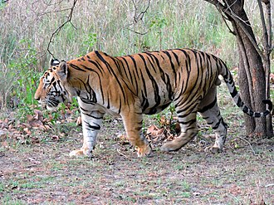
They are the largest in the cat family with incredible power and strength. The tiger lives alone and mark large territories to keep others away. They travel many miles at night to find and track their prey using their distinct and unique markings, by way of camouflage, to move close enough before they attack.
Females will have litters of 3 to 6 cubs who will remain with their mother for at least 3 years before leaving her to find their own territory.
Did you know that … a tiger’s roar can be heard as far as 2 miles away?

Key Facts: Scientific Name - Panthera tigris tigris
Habitat: India, Nepal and China
Population: 2,500 world wide
Type: mammals
Diet: carnivore
Average life span in the wild: 8 to 10 years
Size: head and body: 5 to 6 feet; tail: 2 to 3 feet
Weight: 240 to 500 pounds

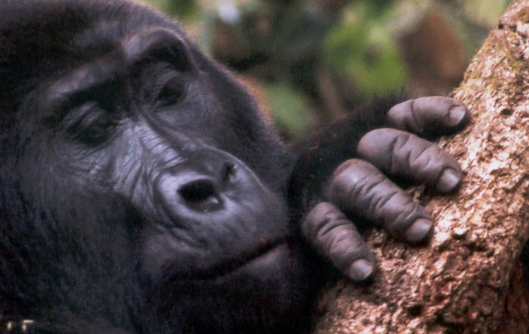
Mountain Gorilla – The Gentle Giant
Surprisingly the Mountain Gorilla was thought to be a mystical animal until the early 20th century when they were discovered by German explorer Robert von Beringe – the latin name reflects his discovery.
Living high in the mountains, they are usually found in family communities of up to 30 gorillas led by a dominant older male called a Silverback. The leader organises the troop in finding plant foods, nesting and moving around their home territory covering anything up to 16 square miles.
Female gorillas give birth to one infant who will cling to its mother’s fur from a young age until they are 2/3 years old. The youngsters share similar behavioural traits to human toddlers during play.
Did you know that … Gorillas in captivity have learned basic human sign language?

Key Facts: Scientific Name: gorilla beringei beringei
Habitat: Rwanda, Democratic Republic of Congo and Uganda
Population: Approx. 900
Type: Mammals
Diet: Omnivore
Group Name: Troop, Band
Average Life Span In The Wild: 35 years
Size: Standing Height: 4 to 6 feet
Weight: 300 to 485 pounds

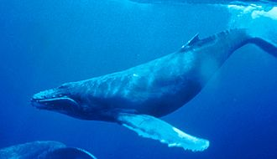
Humpback Whale – Singer/Songwriter of the seas
The humpback whale is one of the largest species of whale which exists today and, despite their immense size, they are very adept at acrobatic performances in the water – it is quite common to see humpbacks propel themselves up and out of the water completely, this is known as breaching behaviour.
They are known as the singer/songwriter of the seas because of their erily haunting songs which can last between 10 and 20 minutes, travel many miles underwater and with dialects unique to the part of the world where the humpback lives. It is thought the songs are a means by which they communicate with each other and attract mates.
Their latin name means “big wing of New England” which refers to their giant pectoral fins up to 16 feet in length and the location where they were first encountered.
Humpbacks whales migrate each year to warmer winter breeding grounds where the calves are born. Females nurse their young for nearly a year although it takes quite a few more for the humpback to fully mature.
Did you know that … Humpback calves are known to “whisper” to their mothers?

Key Facts: Scientific Name: megaptera novaeangliae
Habitat: Earth’s oceans
Population: Between 30,000 and 40,000
Type: Mammals
Diet: Omnivore
Group Name: Pod
Average Life Span In The Wild: 40 years
Size: 48 to 62.5 feet
Weight: 40 tons

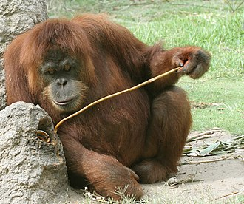
Orangutan – The Person of the Forest
With their long arms and intelligence, Orangutans are close relatives to humans, sharing 97% of the same DNA. The word Orangutan means “people of the forest” in the Malayan language.
Orangutans spend a great deal of time in the trees of their tropical home, sleeping in nests of leafy branches and using large leaves to cover themselves during the rains.
Orangutans tend to be solitary creatures, particularly the males, and as they move through the forest they call out to each other, maintaining distance between them.
Females give birth once every 8 years and the infant will remain with her for 6-7 years, developing all the skills it will need to survive in the wild.
Did you know that … The arm span of a male orangutan can stretch 7-8 feet from fingertip to fingertip, considerably longer than a standing height of 5 feet?
Key Facts: Scientific Name: Pongo
Habitat: Borneo and Sumatra
Population: Estimated 50,000 to 60,000
Type: Mammals
Diet: Omnivore
Average Life Span In The Wild: 30 to 40 years
Size: Standing Height: 4 to 5 feet
Weight: 73 to 180 pounds
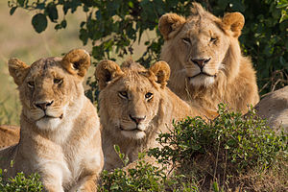
Lions – The King of the Jungle
One of the most feared and revered animals of the wild, the Lion epitomises everything that is courage and strength except, of course, for the cowardly lion in “The Wizard of Oz”.
An adult lion is yellow-gold in colour and only the males sport the magnificient mane of long hairs around their heads.
Lions live in large groups known as a pride with up to 40 cats including males, females and their cubs. These prides have their territory in grasslands, open woodlands and may also live in tropical rainforests and deserts.
Interestingly it is the female lions who travel to outwit and catch their prey. Because other wildlife can run faster than the lions, it is this teamwork which ensures they can provide for themselves and the rest of the pride. Another tact they will try is to steal a kill from hyenas or wild dogs where the hard work has already been done for them.
Did you know that … The film, Born Free, was based on the story of a British senior game warden, George Adamson and his wife Joy who raised the orphaned lion cub Elsa to adulthood, releasing her back into the wilderness of Kenya where she was accepted into a pride?
Key Facts: Scientific Name: Panthera Leo
Habitat: Sub-Saharan Africa and Western India
Population: 25,000 to 30,000 worldwide
Type: Mammals
Diet: Carnivore
Average Life Span In The Wild: 12 to 16 years
Group Name: Pride
Size: Head And Body, 4.5 To 6.5 Feet; Tail, 26.25 To 39.5 Inches
Weight: 265 To 420 Pounds

