Vincent Van Gogh
30 March 1853 – 29 July 1890
Vincent Van Gogh was a Dutch, Post-Impressionist painter. In just over a decade, he created more than 2,000 artworks – around 860 of which were painted using oils, and in the last two years of his life.
His landscapes, still life paintings, and portraits are characterised by their bold and dramatic colours, and impulsive and expressive brushwork.
Van Gogh – sunflower images
Van Gogh began the sunflower paintings in late summer 1888 and continued into the following year. He gave one to his friend, Paul Gaugin, to decorate his bedroom. The paintings depict sunflowers in all stages of life, from withered to full bloom. The paintings were considered innovative due to their use of new pigments in the yellow spectrum.
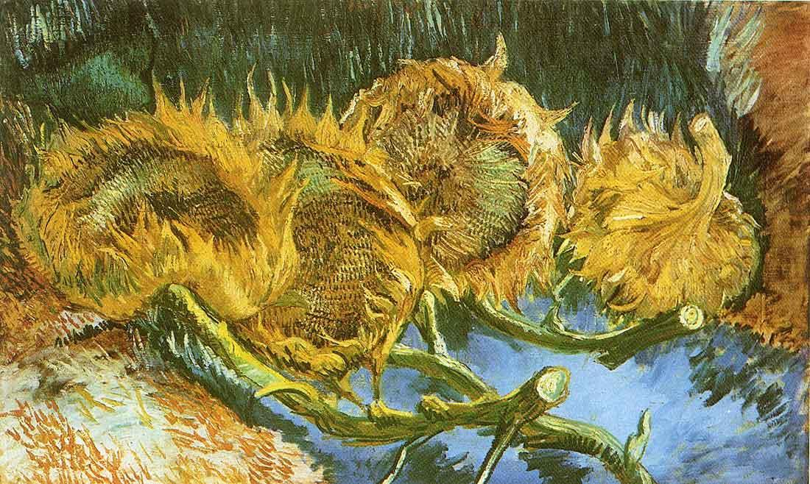
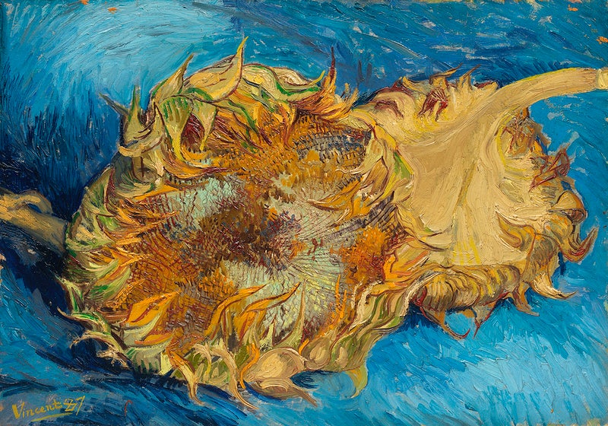
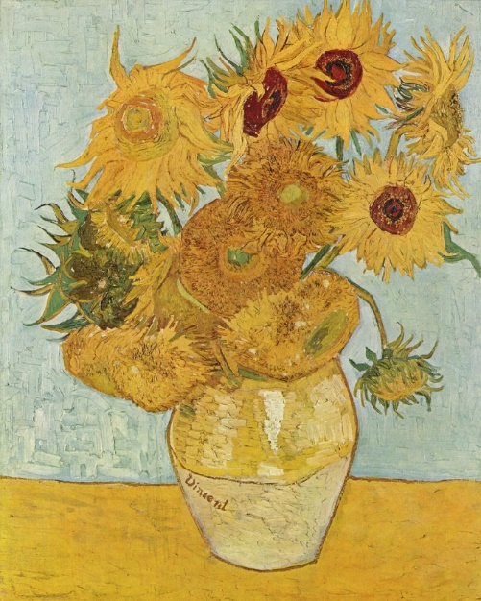
In March 1987, Van Gogh’s ‘Still Life: Vase with Fifteen Sunflowers’ was auctioned at Christies in London for nearly $40 million, bought by a Japanese insurance magnate. It is displayed at the Museum of Modern Art in Tokyo.

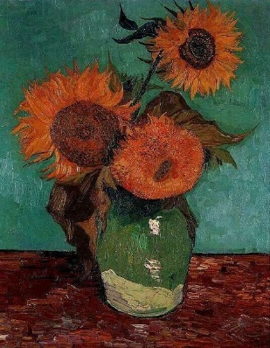
In December 1888, Gaugin painted a portrait of Van Gogh when he visited him in Arles, France. Van Gogh wanted Gaugin to join him and start an artist colony, however the two often quarrelled and Gaugin only stayed a couple of months.
