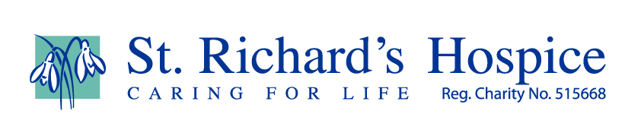

Wimbledon 2020

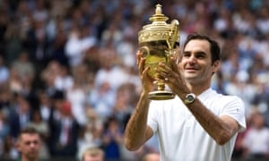
For the first time since the second world war there will be no Wimbledon tournament this year due to the Coronavirus pandemic.

For all those of you who have been missing your tennis “fix” here is a Wimbledon themed quiz for you to try.

- Who was the last British player to reach the gentlemen’s singles final before Andy Murray did it in 2012?

- Can you give the christian names of both Andy Murray’s wife and mother?

- Can you name the American player who knocked out Novak Djokovic in the third round of Wimbledon 2016?

- Who won a mixed doubles title with her brother John in 1980?

- Jean Rene Lacoste was the first ever men’s number one seed when seeding was first introduced in 1927. What animal was his nickname?

- Which men’s player hit a record 212 aces during the 2001 tournament?

- In 2012, Andy Murray was involved in the latest completed match at Wimbledon. What time did it end: (a) 9.02pm (b) 10.02pm (c)11.02pm?

- As at 2015, who holds the record for the fastest female serve of all time at Wimbledon?

- What is ‘parthenocissus tricuspidata’?

- Name the official soft drink supplier to Wimbledon.

- Chris Lewis reached the final in 1983 when he lost in straight sets to John McEnroe. Which country did he represent?

- What is the name of the electronic line calling system introduced on Centre Court in 2006?

- Who won the ladies singles title in 2018?

- What is the name of the Ladies’ Singles Trophy awarded at Wimbledon each year?

- Who won the mens’ singles title in the first year of the new open era in 1968?

- Bjorn Borg won five consecutive titles between 1976 and 1980. Name the two American players that won either side of this run.

- Wimbledon’s Centre Court is often known by its postcode. What is it?

- Since the open era started in 1968, how many ladies’ singles titles have been won by British players?

- The inscription above the entrance to the Centre Court reads ‘If you can meet with triumph and disaster and treat these two imposters just the same’ – which poem do these lines come from?

- Which 18-year-old amateur made it through to the semi-finals in 1977? Who eventually knocked this American out?

- Who did Andy Murray beat in the final to take the 2016 Men’s Singles title?

- Name the only wild card entrant to win the Men’s Singles title.

- Which mother won the Ladies Singles title in 1980.

Answers:

(1) Bunny Austin (2) Kim and Judy (3) Sam Querry (4) Tracy Austin (5) The Crocodile (6) Goran Ivanisevic (7) 11.02pm (8) Venus Williams at 129mph
(9) The ivy on Centre Court (also known as poison ivy) (10) Robinsons
(11) New Zealand (12) Hawkeye (13) Angelique Kerber (14) The Venus Rosewater Dish (15) Rod Laver (16) Arthur Ashe (1975) and John McEnroe (1981) (17) SW19 (18) Two – Ann Jones (1969) and Virginia Wade (1977) (19) ‘If’ by Rudyard Kipling (20) John McEnroe. Jimmy Connors (21) Milos Raonic (22) Goran Ivanisevic (2001) (23) Evonne Goolagon Cawley.
