Traditions at Worcestershire County Cricket Club
For me, one of the greatest pleasures during the summer months is to be a spectator at Worcestershire County Cricket Club.
My husband and I have had the pleasure of watching numerous county, one-day and twenty twenty cricket matches at New Road.
Many cricket fans and commentators nominate Worcester as the prettiest UK county cricket ground. From the pavilion, there are views to the river Severn and Worcester Cathedral. The seats are located close to the action and you always feel involved in the match.
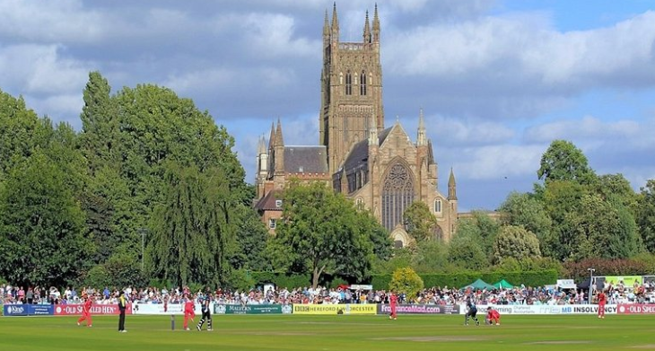
The Worcestershire County Cricket Club was founded in 1865 at the Star Hotel and as such is still a traditional English cricket ground.
One of my earliest memories of a One Day Cup match was the sudden disappearance of people at 2:45 in the afternoon. Where were they are going? It was another hour before the official tea break? They seem to be heading to an old building. By 3pm the queue was down the steps. Afternoon tea is being served in the Ladies Pavilion!

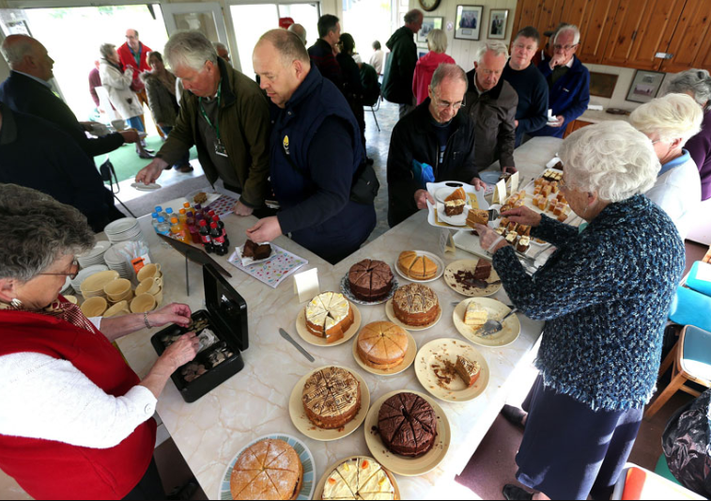

Since 1956 an army of volunteers have provided tea and homemade cakes to the Worcestershire cricket spectators. The assortment of cakes is a sight to behold. As one cake is finished another magically appears. All proceeds from the tea and cake sales are donated to charity which includes the upkeep of chairs at the ground.

At cricket grounds from Perth to Cape Town to Lords, Worcestershire followers have been asked: "Do you still do those amazing afternoon teas with home-made cakes?"

Yes, we do! I’m looking forward to cricket resuming at New Road and another afternoon tea.

By Worcestershire cricket fan, Sharon Ross

