Lea and Perrins Worcestershire Sauce
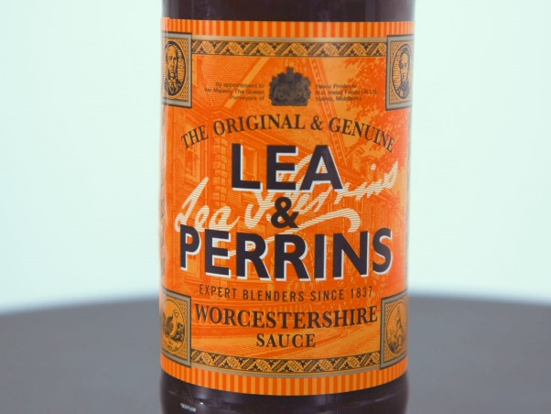
Worcestershire Sauce is a fermented liquid condiment created in Worcester during the first half of the 19th Century.
The creators were chemist John Wheeley Lea and William Henry Perrins.
The Lea and Perrins brand was commercialised in 1837.
The packaging originally stated that the sauce came from ‘the recipe of a nobleman in the county’.
The company also claimed that Lord Marcus Sandys, ex-governor of Bengal, encountered it whilst in India with the East India Company in the 1930’s, and commissioned the local apothecaries (Lea & Perrins) to recreate it.
According to legend, when the recipe was first mixed, it was so strong it was considered inedible and the barrel was abandoned in the basement. A few years later, looking to make a storage room, the chemists tasted it again and discovered the fermentation process had mellowed the sauce and it was now palatable. In 1838 the first bottles of Lea and Perrins were sold to the public.
In October 1897, Lea and Perrins relocated manufacture of their sauce from their pharmacy in Broad Street to a factory on Midland Road.
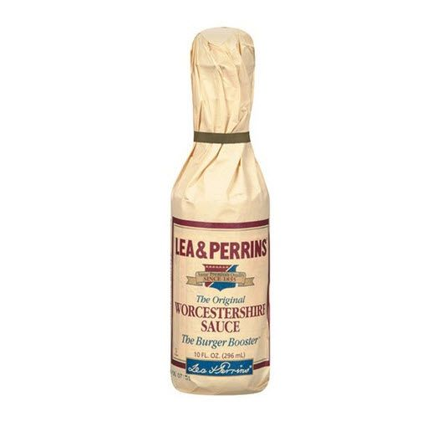
In 1930 Lea and Perrins was bought by HP Foods, which was then later acquired by Imperial Tobacco Co. in 1967. HP was sold to Danone in 1988 and then to Heinz in 2005.
The factory on Midland Road still produces Lea and Perrins ready mixed bottles for domestic use and a concentrate for bottling abroad.
Due to a shortage in World War Two, Lea and Perrins switched from using soy sauce to hydrolysed vegetable protein. Packaging around the world varies. The bottle packaged in paper on the right is how it is sold in the US.
Why not research some recipes using this local, speciality product?

