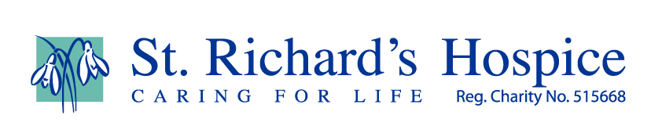

A Sporting Chance – all the answers are sport related
- Don’t fall at this first one or you’ll never get on track (7)

- Horses causing a raquet go on trial (9)

- The day after Christmas (6)

- Billy Elliot’s favourite routine (6)

- Ping pong (5,6)

- Six Nations E,W,I,S,F,I (5)

- The sport of Robin Hood (7)

- You do this on the internet (4)

- You’re skating on thin ice if you miss this one (3,7)

- Lemon, orange or blackcurrant (6)

- Don’t get burnt by the ashes, it just ain’t ….. (7)

- 2012 London (8)

- Oxford or Cambridge (4,4)

- Where the Wombles live (9)

- Baddiel and Skinner fantasy league (8)

- On your bike (7)

- 180 (5)

- End at the 18th hole or you’re crazy (4)

ANSWERS
- Hurdles 2. Badminton 3. Boxing 4. Ballet 5. Table Tennis 6. Rugby 7. Archery
8. Surf 9. Ice Skating 10. Squash 11. Cricket 12. Olympics 13. Boat Race
14. Wimbledon 15. Football 16. Cycling 17. Darts 18. Golf

