ST RICHARD’S HOSPICE

JOB DESCRIPTION

Job Title: Assistant Shop Manager

Hours: 30 hours per week worked over 4 days

Pay Point: 3

Reporting to: Shop Manager

Accountable to: Regional Manager/ Commercial Director

Our Values:
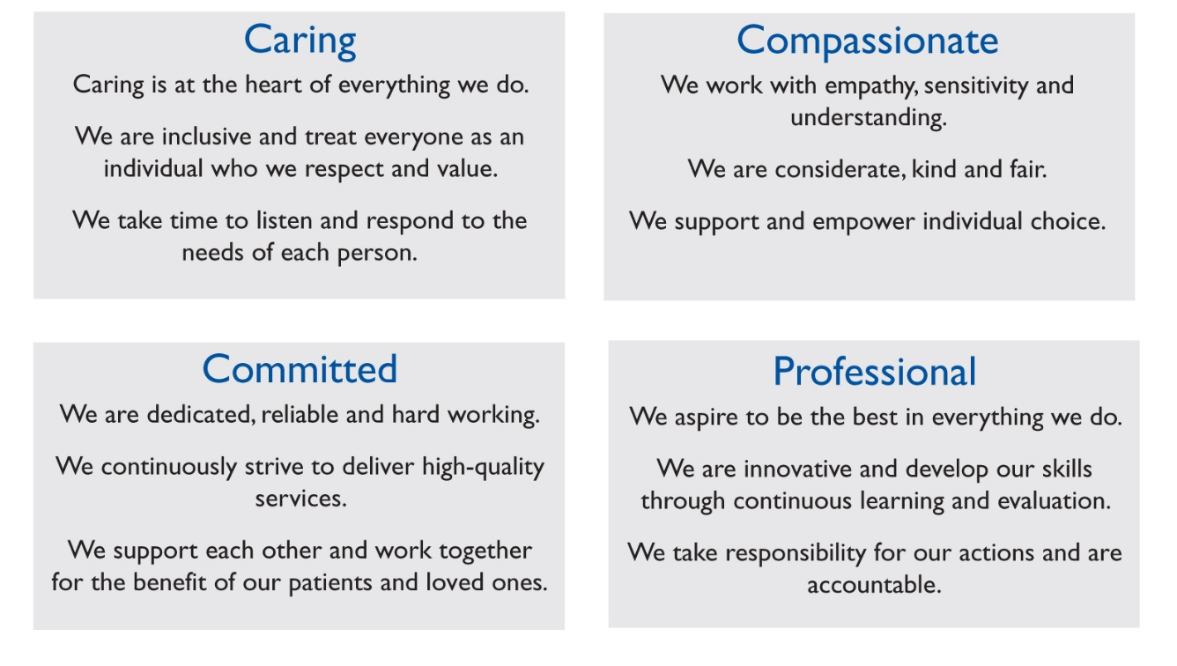

Job summary:

To work flexibly to assist in the efficient running of St Richard’s Hospice
Shops. To assist the Shop Manager to achieve optimised sales and be
responsible for the day to day running of the store in the absence of the
Manager. To provide high levels of customer service at all times. To
assist in the recruitment and management of volunteers, stock levels,
sorting and pricing, administration and stock movement.

- Main Duties & Responsibilities:

  - To provide excellent customer service promoting the shop to the local community and beyond.

  - To assist customers with furniture purchases and arrange deliveries and collections as required

  - To ensure that all basic shop procedures are adhered to.

  - To ensure that goods are presented in a way that maintains the high standard and quality customers have come to expect from St. Richard’s Hospice shops.

  - To arrange furniture in a safe and appealing manner to maximise sales

  - To ensure that all areas of the shop premises are clean, tidy and well organised at all times.

  - To be aware that certain donated goods may be of considerable value, and to secure these goods until they have been professionally valued.

  - To ensure that donated goods are correctly priced with reference to the Pricing Guide.

  - To be flexible with hours of work to cover for days off
and holidays of other paid staff.

  - To ensure consistency in the recruitment , management and training of volunteers to facilitate smooth running of the shop.

1.8 To inform the Regional Manager of any problems relating to the welfare of our volunteers, and to be aware of the value of volunteers, who give their time willingly for the benefit of the Hospice.

1.9 To ensure that all returns and paperwork are submitted to Head Office accurately and in appropriate timescales.

1.10 To attend any meetings, training or conference that has relevance
to the role as directed by management.

  - To undertake any other reasonable duties as and when required.

1.12 To undertake annual IPR with Line Manager as appropriate, and
respond to the agreed development plan in personal development.

  - To promote the work of St Richard’s Hospice at all possible times

  - To deputise for the shop manager in her absence.

2 Health & Safety

  - To complete mandatory in-house updates on fire and safety, moving and handling etc.

  - To be aware of the responsibilities placed on employees under the Health and Safety at Work Act, to maintain a safe environment for employees and visitors.

  - To bring concerns to the attention of the Regional Manager.

This job description is not exhaustive and is subject to review at Individual Performance Review . All staff employed by St Richard's Hospice are required to comply with Policies and Procedures within the organisation to include Health and Safety, Equal Opportunities, Confidentiality and Information Governance.

Signed………………………………… Date…………………………………..

