ST RICHARD’S HOSPICE
JOB DESCRIPTION

Job Title: Therapy Support Assistant
Occupational and Physiotherapy
Responsible to: Therapy Team Leader
Accountable to: Head of Living Well Services
Our Values:
Our Core Values underpin everything we do and all employees are expected to comply with our Values and reflect these in their day to day work.
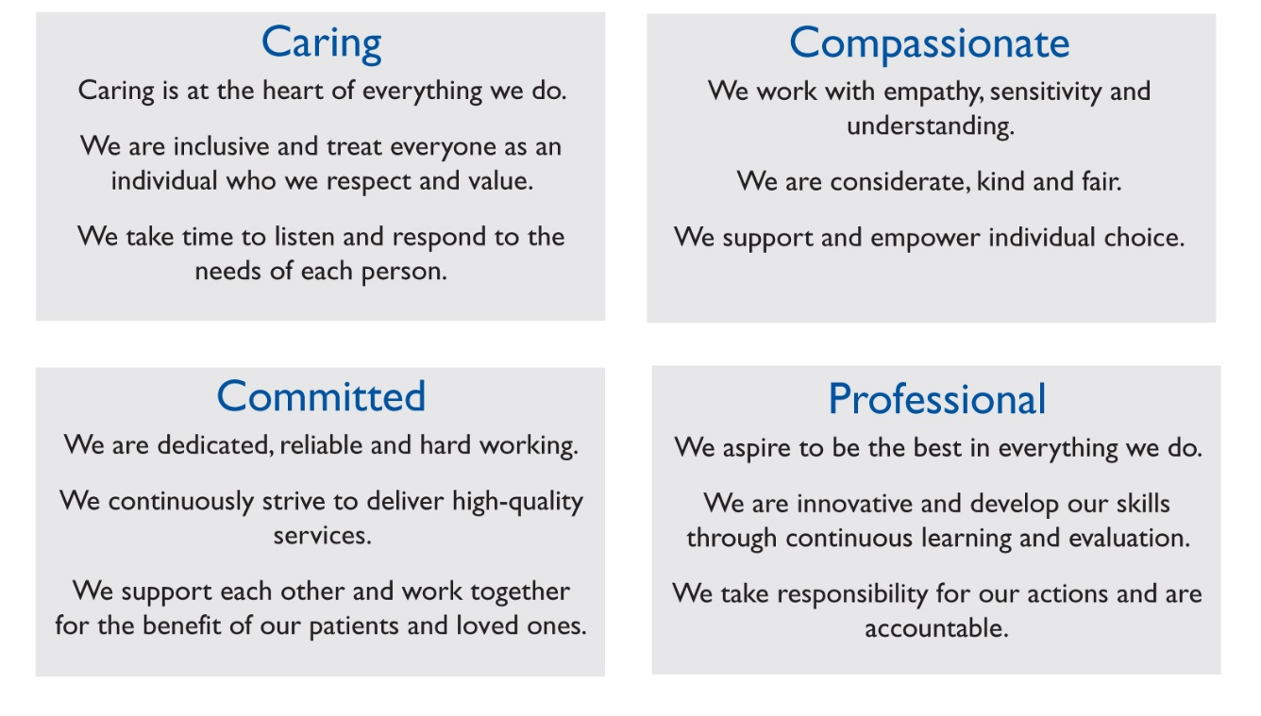
Job Summary
- To provide support to the Therapy team in the planning and delivery of a range of interventions and programmes of care to support the rehabilitative approach to care and support of patients requiring palliative care. To support patients and carers, virtually or face to face depending on the need.

To independently deliver the interventions as part of the therapy team, evaluating the progress of patients against a set of outcome measures.

To effectively communicate with patients and other team members to ensure excellent quality of care using excellent communication skills (written and verbal).
To maintain excellent working relationships with the team and notify the therapists immediately if there are concerns about a patient’s progression, safety or wellbeing.

To support the Physiotherapy and Occupational Therapy departments as required.

Main Duties and Responsibilities
- Clinical
- To undertake all aspects of clinical duties and to carry a full caseload of patients under the supervision of the qualified therapists
- Be competent in the delivery of simple treatment interventions specifically designed for the management of fatigue, breathlessness and other symptoms.
- To be competent and confident in the leading of therapeutic group work and drop in sessions.
- Progress patients with rehabilitation programmes to maximise function and independence.
- Support patients to carry out planned exercise programmes within a gym environment or their own home.
- To assist with fitting equipment in the Hospice or in patients’ homes to facilitate independence.
- To conduct non-complex assessments under the direction of the Occupational and Physiotherapists.
- Promote understanding of the aims of the therapy to ensure compliance and progression through the planned programmes of care.
- To attend and participate in multi-disciplinary team meetings, case conferences and handovers to ensure the coordination of patient care.
- To employ appropriate skills to gain cooperation in the progression of the agreed programmes of care.
- Maintain accurate clinical records of all interventions in line with Hospice policy and guidelines.
- To collect data, statistics and information as required.
- To complete onward referrals and signposting patients to other services as required
- To be proactive in supporting therapists with patient led goal setting.
- To work in partnership with the local GP’s, NHS service providers and other agencies developing professional, seamless and transparent working relationships whilst being an advocate for patients.

- Professional
- Promote quality patient care at every contact
- Act as a role model demonstrating high standards of care and providing clinical leadership for colleagues
- To be aware of own limitations and refer to qualified therapists when necessary.
- To assist in the prioritising and managing of referrals
- Manage a caseload of complex patients promoting the highest possible standards of individualised care and symptom control through a process of assessment, planning, implementation and evaluation under the supervision of the qualified therapists.
- Liaise with community teams to obtain relevant care records and clinical information
- Assist with holistic assessments in newly referred patients, plan care on their needs and ensure all discussions and plans are accurately recorded and documented.
- Responsible for identifying and acting on any risk of safeguarding to patients and their families in accordance with St Richard’s Hospice, Safeguarding of Vulnerable Adults and the Safeguarding of Children Policies and Procedures.
- To adhere to Hospice systems for incident reporting.
- To maintain good effective communication with all staff at St Richards Hospice, other Hospices, Hospitals, Home Care Teams and Primary Healthcare Teams, and Clinical Nurse Specialists.
- To assist in the smooth running of the therapy department, ensuring equipment stock is in order.

- Educational
- To contribute to the teaching of other healthcare professionals both internally and externally
- To undertake appropriate training to ensure competence to practice and as directed by the line manager
General
All staff are required to abide by St Richard’s Hospice policies and procedures, including confidentiality, equal opportunities and data protection.
Uphold the St Richard’s Hospice ethos and demonstrate behaviours in line with our shared values of Caring, Compassionate, Committed and Professional.

This job description is not exhaustive and may be reviewed on agreement of the post holder and Line Manager.

Signed……………………………………………………Date……………………………..

