ST RICHARD’S HOSPICE

JOB DESCRIPTION

Job Title: Clinical Nurse Specialist - Entry

Reports to: Community Nursing Services Manager

Accountable to: Care Director

Based at: St Richard’s Hospice

Our Values:
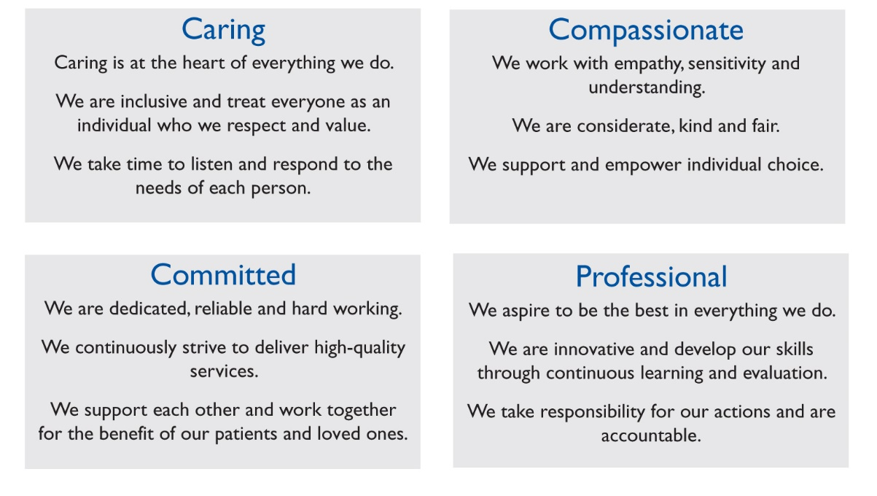

Job Summary:

To provide a responsive, flexible, high quality community specialist palliative care services, 24 hours per day, 7 days per week, to patients and their families, ensuring that the service delivered reflects the Hospice strategic priorities and upholds Care Quality Commission requirements.

To work autonomously in the community to provide specialist assessment of patients with complex palliative care needs, develop management options, advising others involved with the patient’s care and evaluate the plan in the face of changing needs.

To work with multi-disciplinary team members, contributing to education programmes for a variety of professionals and organisations.

To work collaboratively and co-operatively with clinical colleagues to contribute to the continual development of services and quality of care delivered.

KEY RESPONSIBILITIES

Clinical
- To manage a complex caseload of patients, prioritising need using advanced clinical reasoning based on professional, evidence based knowledge.
- To perform comprehensive assessment of patients with sensitive and complex palliative care needs and assess family member/care needs. Plan, implement and evaluate care delivery according to changing health care needs, wishes and culture.
- To work with patients and carers in a therapeutic way to address physical, psychological, spiritual and social needs.
- To advise others involved in the care of the patient, using in-depth knowledge of the options for achieving symptom control. To undertake regular medication reviews in relation to palliative care.
- To discuss treatment options and work in partnership with patients and carers to enable them to make informed choices and set goals.
- To facilitate discussions around advance care planning, providing information and assisting with completion of documentation as required. Make informed decisions regarding resuscitation, and discuss these with patients and carers as appropriate, communicate with professionals and ensure all documentation is complete.
- Within specialist assessments, identify issues which are deemed to be actual or potential palliative care crises and develop action plans involving other professionals, the patient and family members as appropriate.
- To develop and implement a plan of care, including investigations, admissions, out-patient appointments, referral to other disciplines or services as appropriate.
- To utilise advanced communication skills to communicate highly complex information to carers, relatives and professionals, acting as patient advocate and addressing barriers to understanding
- To undertake comprehensive health assessment
- To undertake effective team clinical supervision and reflection on a monthly basis
- To liaise with the In-patient Unit and Living Well Services regarding discharges, ensuring continuity of care.
- Present cases clearly, consistently and professionally in a variety of settings including multi-disciplinary meetings, to GP’s and case conferences and communicate effectively throughout meetings.
- To work collaboratively with other professionals and agencies to ensure patient needs are met, especially in relation to on-going care needs.
- To work collaboratively with other professionals and agencies to ensure patient needs are met, especially in relation to on-going care.
- To develop a trusting relationship with family members supporting them to care for patients, preparing them for end of life issues and needs, impending loss and grief. To assess need for bereavement service referral and undertake initial post-bereavement support.
- To collect, collate, evaluate and report information, maintain accurate patient records both written and electronic.
- To keep up to date with the latest evidence base, theories and new activity in relation to practice.
- After completion of probationary period, to take part in the CNS on call rota and weekend CNS rota as required, providing access to specialist palliative care advice outside normal working hours.
Educational
- To promote, through education, expertise in Palliative Care, to both internal staff and outside agencies, acting as a role model at all times.
- To identify, generate and utilise appropriate learning opportunities in practice.
- To assess the educational needs of patients, carers and staff and respond appropriately.
- To provide education, advice and support and mentorship to students
- To work with St Richard’s Hospice Education Department to develop methods of bridging the theory/practice gap and promote research based practice.
- To support the culture of continuous learning within the department.
- To ensure own compliance with regard to NMC regulations, mandatory training and continual professional development to ensure clinical effectiveness.
- To develop and sustain networks with other experts at local and national level.
Clinical Governance/Quality
- To conduct and document risk assessments in respect of clinical care or self and take appropriate action. Ensure lone working policy is followed.
- To identify near misses and incidents via electronic incidence reporting system and document and address these in a timely way, ensuring appropriate action and communication.
- Ensure care is evidence based where available and comply with policies, procedures guidelines and professional body guidance adopted by St Richard’s Hospice.
- To participate in regular peer review of caseload.
- To utilise research findings in the delivery of specialist palliative care and disseminate relevant findings to other staff.
- To co-operate and support clinical practitioners wishing to undertake research projects within the hospice, community or local trust.
- To contribute to any audits and evaluation of service provision and the implementation and monitoring of guidelines, standards, policies in order to improve effectiveness of patient care.

Management
- To manage work time effectively ensuring that appropriate time frames are set aside for administration, education and clinical supervision.
- To manage a complex caseload to include:
- using specialist palliative care eligibility criteria to admit and discharge from caseload
- manage caseload demands according care needs
- address planned and emergency clinical issues
- communicate with a variety of professionals and services
- To assist the Team Manager in evaluating and developing specialist palliative care services further.
- To contribute to efficient day to day co-ordination of the Department.
- To represent Community Nursing Services on committees and projects as required.
- To promote partnership working across the hospice and with outside agencies.
- To provide a leadership model that demonstrates expert knowledge and high standards of clinical practice.
Professional Responsibility
- To maintain registration with the Nursing and Midwifery Council and act in accordance with NMC Code of Professional Conduct and Standards.
- To maintain high professional standards utilising the St Richard’s Hospice training and competency passport for Clinical Nurse Specialists (CNS)
- To maintain accurate records in accordance with confidentiality, Data Protection and Information Governance.
- To participate in regular managerial supervision including one to ones, review of competencies passport and Individual Performance Review (IPR) and respond to agreed development plan
- To ensure all St Richard’s policies, procedures and guidelines are adhered to including Information Governance, Health and Safety, Equal Opportunities, Confidentiality etc.

This job description is not exhaustive and may undergo amendment by agreement with the post holder and manager.

Signed……………………………………………Date………………………………

Clinical Nurse Specialist - Entry
Person Specification

 | Essential | Desirable
Qualifications/ Training | RGN Registration  Advanced communication skills training (or willing to work towards)  Full driving licence  Professional Portfolio | Teaching qualification
Experience/ Knowledge | Post registration experience in a variety of settings  Experience at completing comprehensive holistic assessments of patient needs  Experience of managing a caseload  Teaching experience  Experience of communicating complex, sensitive issues with patients, carers and professionals  Experience of multi-disciplinary and agency working  Awareness of key policy drivers  Experience of participating in service development | Experience of telephone assessment of patients’ needs  Knowledge of advanced care planning  Experience of working with palliative and end of life patients as a Community nurse  Experience of service development  Experience of triaging calls or willing to learn
Skills/ Abilities | Able to demonstrate clear and advanced written, verbal and non-verbal communication skills  Understanding of and ability to implement aspects of the clinical governance agenda  Ability to establish and maintain credibility with a diverse range of professionals and lay people  Demonstrate ability to identify personal development needs, fulfil them and apply learning to practice  Excellent planning and organisation skills  Ability to assess risk regarding self and others and take appropriate action  Ability to apply effective leadership skills responsive to a variety of circumstances  Able to work independently and deliver objectives within given timeframe  Computer literacy, including maintenance of electronic patient records  Ability to work as a team member
Personal Qualities | Ability to form professional relationships within a multi-disciplinary team  Flexibility to support the wider teams as required  Ability to identify own learning needs and develop skills pertaining to the role  Excellent interpersonal skills  Motivated and enthusiastic  Flexible attitude and approach with the ability to participate in out of hours on call rota  Ability to manage own workload  Able to analyse, problem solve and prioritise  Positive professional approach and image  Ability to manage the emotional impact of working within Palliative Care  Supportive of the ethos and strategic objectives of St. Richard’s Hospice  Ability to undertake the full scope of duties as outlined in the Job Description

