**ST RICHARD’S HOSPICE**

**JOB DESCRIPTION**

**Title:**  Kitchen Assistant/Café Assistant

**Reporting to:** Chef Manager

**Accountable to:** Head of Estates & Facilities

**Our Values:**

Our Core Valuesunderpin everything we do and all employees are expected to comply with our Values and reflect these in their day-to-day work.

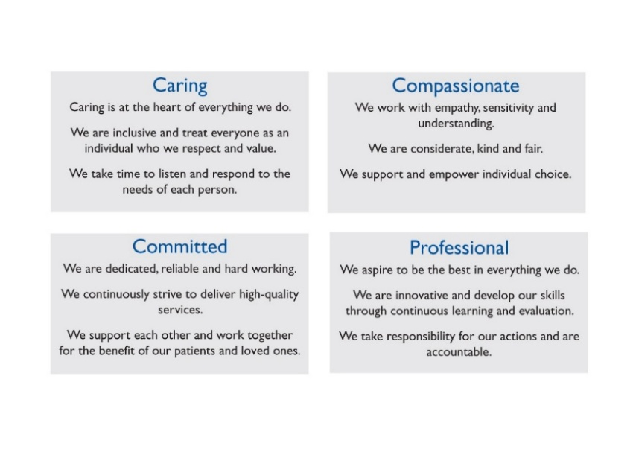

**Job Summary**

You will be part of a catering team committed to ensuring that food and drink is nutritious, appetising and appropriate for patients' medical and cultural needs. You will work alongside other members of the catering team to ensure a high quality catering service is provided. The role will include washing up, maintaining a high standard of cleanliness and complying with food hygiene regulations. You will have a flexible attitude to work in all areas of the catering service, including preparing sandwiches and a customer service role in the restaurant.

**Key Duties and Responsibilities:**

* Ensure all washing up, drying and putting away of crockery, utensils and cookware is regularly done to a high standard throughout the day
* Ensure all areas of the kitchen and servery are maintained to a high standard of cleanliness following the hospice cleaning schedules, hygiene regulations and procedures, recording all results
* Learn the complexities and understand the importance of special diets and maintain awareness of new legislation regarding food safety, allergens and special diets
* Ensure the highest possible quality is maintained and that agreed standards for food preparation and presentation are met at all times
* Assist the chefs with preparation of vegetables, salads and other cooking tasks
* Prepare packaged goods for sale, ensuring correct pricing, allergen information and food information is provided.
* Prepare sandwiches, toasties and baguettes as required
* Serve meals and drinks, including barista style coffee to customers in the restaurant
* Handle cash and credit card payments and restock items for purchase
* Set up and help prepare catering for functions, meetings and fundraising events, assist with serving at events as required
* Be mindful of cost, working to minimise wastage of food and other products used
* Assist with stock taking, record keeping, ordering and deliveries
* Carry out daily and weekly procedures, including temperature checks, food labelling, dating and storage to maintain high levels of due diligence
* Work in all areas of the kitchen and café and cover absences of Kitchen Assistants, Hospitality Co-ordinator and Café Staff
* Ensure a high standard of personal hygiene is maintained with clean uniform at all times
* Attend appropriate updates and courses to maintain and develop own skills and expertise
* Complete all in house mandatory training as required
* Be aware of health and safety issues within the workplace and bring concerns to the attention of line manager
* Undertake annual appraisal and respond to the agreed objectives and personal development plan
* All staff employed by St Richard’s Hospice are bound by Policies and Procedures within the organisation to include Health and Safety, Equal Opportunities and Confidentiality

**Personal Education and Development**

* To maintain registration/membership of [insert professional body]- delete if not applicable
* To use the hospice IT systems appropriately to maintain records and communicate internally and externally
* To maintain own personal development by attending appropriate courses and updates to maintain and develop skills and expertise
* To participate in the Individual Performance Review (IPR) process and respond to the agreed development plan
* To undertake statutory, mandatory and role enhancement training as directed

**General**

* To be aware of health and safety issues within the workplace and bring concerns to the attention of the line manager
* All staff are required to abide by St Richard’s Hospice policies and procedures, including confidentiality, equal opportunities and data protection.

**ST RICHARD’S HOSPICE**

**PERSON SPECIFICATION**

**Job Title:** Kitchen Assistant/Café Assistant

**Reporting to:** Chef Manager

**Accountable to:** Head of Estates & Facilities

|  |  |  |
| --- | --- | --- |
|  | **Essential** | **Desirable** |
| Education, Qualifications and Training | Basic or intermediate food hygiene certificate  Good standard of general education including numeracy, literacy and IT skills | NVQ level 1 or 2 in food preparation & cooking  Driving license  Allergen awareness training |
| Knowledge | Working knowledge of HACCAP, Infection Control and Health and Safety | Knowledge of café systems and ‘barista’ coffee making |
| Experience | Experience of working in a catering team and/or café environment  Experience of preparing food to high standards of quality and presentation  Experience in a customer service role  Experience of working alone and within a team  Good communication and organisational skills | Experience within a healthcare environment  Experience of working with volunteers as part of a team |
| Skills and Abilities | Excellent customer service skills with a ‘nothing is too much trouble’ attitude  Able to work quickly and efficiently whilst paying attention to detail and keeping standards high  High standards of cleanliness, personal hygiene and appearance at all times |  |
| Personal Qualities and Aptitudes | Passion to deliver high quality food to patients, staff and customers  Empathy with the ethos of the hospice movement and able to communicate with patients, staff and volunteers  Be able to react quickly to kitchen emergencies and to prevent accidents  Flexible attitude towards working patterns and willingness to cover for other staff absences  Able to work on own initiative and as part of a team |  |