ST RICHARD’S HOSPICE

JOB DESCRIPTION

Job Title: Housekeeper

Responsible to: Estates and Facilities Manager

Accountable to: Head of Estates and Facilities

Our Values:

Our Core Values underpin everything we do and all employees are expected to comply with our Values and reflect these in their day-to-day work.

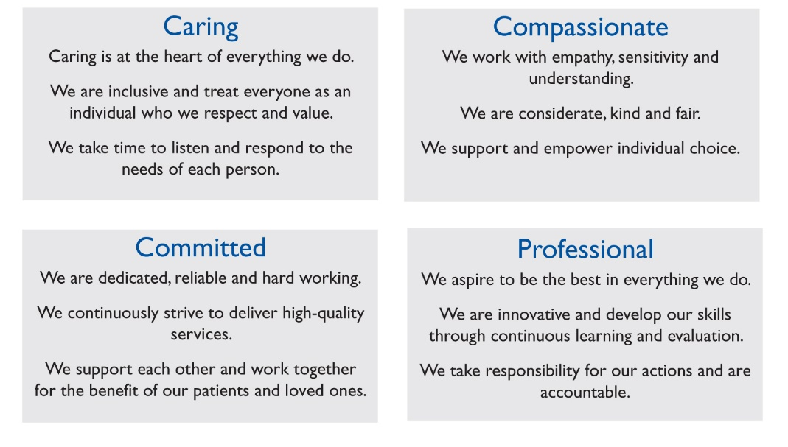

Job Summary:

To work as part of the housekeeping team to provide a clean and safe environment for patients, staff, and visitors. Undertake a wide range of cleaning and laundry duties to exceptionally high standards to meet the National Cleaning Standards. A flexible approach to working is required.

Main Duties and Responsibilities: -

- To thoroughly clean patient bedrooms and bathrooms, including wet/dry cleaning of floors and damp dusting of high- and low-level surfaces. This will include bedrooms occupied by patients as well as vacant rooms.
- Ensure appropriate equipment is used in the area being cleaned and follow all infection control procedures including the colour coding system as per the cleaning policy
- Clean all on site toilets, bathrooms and sluice rooms
- Clean kitchenette and restaurant areas, using mechanical equipment as required
- Daily replenishing of stocks of soap, paper towels and other consumables
- Empty general waste, clinical waste and recycling bins, moving bags to collection points whilst adhering to infection control and waste management policies
- Clean clinical and non clinical areas, including meeting rooms and offices
- Clean furniture, carpets and internal windows as per the cleaning schedule
- Clean equipment after use and be responsible for maintaining the cleanliness and tidiness of the store rooms
- Work in the laundry loading all washing bags into washing machines and washing on appropriate cycle to remove dirt & contamination, removing and loading of tumble dryers
- Iron linen and clothing items user rotary ironer and hand iron and replenish linen stores
- Update electronic records to demonstrate work has been completed
- Be prepared to set up refreshments for hospice meetings and clear rooms afterwards if required
- Participate and contribute to team meetings
- Adhere to hospice policies and procedures e.g. Cleaning Policy, Basic Food Hygiene, Health & Safety, COSHH regulations, Infection Control and Waste Management
- Observe good personal and food hygiene practices at all times, working in a hygienic manner, observing the correct use and care of equipment
- Maintain a clean and tidy appearance and wearing uniform and protective clothing provided in accordance with policies

Personal Qualities:

- In addition to those listed on the person specification, Housekeeping Assistants will need to be comfortable working in rooms occupied by palliative care patients and communicating with them and their loved ones

General:

- All staff employed by St Richard’s Hospice are bound by policies and procedures within the organisation to include health and safety, equal opportunities and confidentiality
- This job description is not exhaustive and will be reviewed annually at IPR by post holder and line manager

Personal Education and Development

- To attend appropriate updates and courses to maintain and develop own skills and expertise.

- To be aware of health and safety issues within the workplace and bring concerns to the attention of the Estates & Facilities Manager.

- To maintain own personal development by attending appropriate courses and updates to maintain and develop skills and expertise

- To participate in the Individual Performance Review (IPR) process and respond to the agreed development plan

- To undertake mandatory training as directed

General

- All staff are required to abide by St Richard’s Hospice policies and procedures, including confidentiality, equal opportunities and data protection.

This job description is not exhaustive and duties may be reviewed from time to time and revised and updated in consultation with you.

Signed…………………………………………………Date………………………………..

ST RICHARD’S HOSPICE

PERSON SPECIFICATION

Job title: Housekeeping Assistant

Responsible to: Estates & Facilities Manager

Accountable to: Head of Estates and Facilities

 | Essential | Desirable
Education, Qualifications and Training | Good standard of general education
Experience | Cleaning experience to a high standard | Cleaning experience in a healthcare setting
Knowledge | Good communication skills | Working knowledge of Health and Safety and Infection Control regulations
Skills and Abilities | Basic computer skills
Personal Qualities and Aptitudes | Self-motivation and ability to work unsupervised  Ability to work as part of a team  Empathetic approach to working with families, patients and healthcare professionals  Proactive and flexible  High standard of personal appearance  Physically fit, able to stand and walk for most of the shift. Able to bend and reach to dust. Able to push cleaning trolleys and lift equipment and supplies  Resilience

